Contents

1 Introduction 1

2 Description of fundamental weather elements 3

2.1 Ordinary weather cells 3

2.2 Supercell thunderstorms 5

2.3 Sounding and its representation 10

2.4 Description of Tornadoes 12

2.5 Tornadogenesis 15

3 Description of the 16 April, 2011 Mid-Atlantic Frontal Storm and the Embedded Raleigh Tornado 18

4 Numerical code 20

4.1 Initial conditions 21

4.2 Pre-processing 27

4.2.1 Reduction of the domain 27

4.2.2 Initialization 28

4.3 Post-processing 36

5 Results of the simulations 40

5.1 Domain size importance 41

5.2 General results 46

5.2.1 Pressure 46

5.2.1 Vertical Velocity Behavior 60

5.2.2 Vorticity 66

5.2.3 Reynolds stresses 69

6 References 73

List of Figures

Figure 1. Life cycle of an ordinary thunderstorm cell 4

Figure 2. Schematic representation of a supercell thunderstorm, adapted from the conceptual model of Lemon and Doswell (1979). 6

Figure 3. Schematic of surface conditions common with a supercell thunderstorm adapted from Lemon and Doswell (1979). 7

Figure 4. Schematic of inner structure of a supercell thunderstorm 8

Figure 5. Sounding and hodograph for Raleigh, N.C., weather event near the time when the outbreak occurred. Plot generated using the operational Numerical Weather Prediction data and reproduced from NOAA’s Rapid Update Cycle web site in real time. 11

Figure 6. Legend of the wind barb points from Unisys website. 11

Figure 7. Tornado with multiple suction vortices. 13

Figure 8. Tilting and stretching of the horizontal vorticity (Markowski et al.; 2009) 16

Figure 9. Series of supercells over North Carolina at 2003UTC, 16 April 2011 19

Figure 10. The Raleigh supercell just before encountering the city. 19

Figure 11. Sounding description in a supercell environment 23

Figure 12. Skew-T diagram representing the sounding for the reference case. Solid line represents the sensible temperature and the dashed line the dewpoint temperature. 25

Figure 13. Skew-T diagram representing the sounding for the wet case. Solid line represents the sensible temperature and the dashed line the dewpoint temperature. 26

Figure 14. Skew-T diagram representing the sounding for the dry case. Solid line represents the sensible temperature and the dashed line the dewpoint temperature. 27

Figure 15. Refine grid boundaries for the wet case. The original grid was cut on the white dotted lines. 28

Figure 16. Simulated Radar Reflectivity at 1000 m altitude at 20 min for the reference case. 31

Figure 17. Simulated Radar Reflectivity at 1000 m altitude at 40 min for the reference case. 32

Figure 18. Simulated Radar Reflectivity at 400m, from left to right, for (a) the reference case with the original grid at 40 min of original simulation, (b) the cut grid, and (c) the refined grid at 0 min of the new simulations. 35

Figure 19. Zoom on a difference between solutions using resized domain (a) and refined domain (b). 36

Figure 20. Post-processing flowchart 38

Figure 21. Particle representation with no discrimination regarding the particle selection 39

Figure 22. Particle representation with discrimination of particle motion 40

Figure 23. Radar reflectivity results showing the importance of the computational domain for (a) the original simulation, (b) the simulation for a 40 km x 40 km grid and initialized with the sounding data, but without the restart file, and (c) the simulation for a 40 km x 40 km grid and initialized with the restart file. 42

Figure 24. Radar Reflectivity for the reference case at an elevation of 400m above the ground. The original grid is represented on the left and the refined grid on the right. From top to bottom, the times are t=40min, t=50min, and t=60min for the original simulation and t=0, t=10min, t=20min for the new simulation. 43

Figure 25. Radar Reflectivity for the wet case at an elevation of 400m above the ground. The original grid is represented on the left and the refined grid on the right. From top to bottom, the times are t=40min, t=50min, and t=60min for the original simulation and t=0, t=10min, t=20min for the new simulation. 44

Figure 26. Radar Reflectivity for the dry case at an elevation of 400m above the ground. The original grid is represented on the left and the refined grid on the right. From top to bottom, the times are t=40min, t=50min, and t=60min for the original simulation and t=0, t=10min, t=20min for the new simulation. 45

Figure 27. Surface Pressure History. Red line represents the reference case, green the wet case, and blue the dry case. The solid lines are the minimum pressure and the dashed lines are the maximum pressure at the surface. 48

Figure 28. Minimum and Maximum Pressure History inside the domain. Red line represents the reference case, green the wet case, and blue the dry case. The solid lines are the minimum pressure and the dashed lines are the maximum pressure 49

Figure 29. Minimum pressure over the simulation times and altitude. (a) reference case, (b) wet case, and (c) dry case. 50

Figure 30. Minimum Pressure History inside the domain for the reference case. The red plain line represents the domain pressure, and the red dash line the surface pressure. 51

Figure 31. 8 mb pressure deficit and cloud prespective for the reference case at t = 5min (1), 13.5 min (2), and 20 min (3) of the simulation. 53

Figure 32. Minimum Pressure History inside the domain for the wet case. The green plain line represents the domain pressure, and the green dash line the surface pressure. 54

Figure 33. 8 mb pressure deficit and cloud prespective for the wet case at t = 5min (1), 10.5 min (2), and 18.5 min (3) of the simulation. 56

Figure 34. Minimum Pressure History inside the domain for the dry case. The blue plain line represents the domain pressure, and the blue dash line the surface pressure. 57

Figure 35. 3 mb pressure deficit and cloud prespective for the dry case at t = 11 min (1), 16.5 min (2), and 17.5 min (3) of the simulation. 59

Figure 36. Minimum and Maximum Vertical Velovity History inside the domain. Red line represents the reference case, green the wet case, and blue the dry case. The solid lines are the minimum velocity and the dashed lines are the maximum velocity. 61

Figure 37. Maximum and minimum velocity over the simulation times and altitude. (a) reference case, (b) wet case, and (c) dry case. 63

Figure 38. Vertical velocity History inside the domain for the reference case. The plain red line represents the minimum vertical velocity, and the dash red line the maximum vertical velocity. 64

Figure 39. Vertical velocity History inside the domain for the wet case. The plain green line represents the minimum vertical velocity, and the dash green line the maximum vertical velocity. 65

Figure 40. Vertical velocity History inside the domain for the dry case. The plain blue line represents the minimum vertical velocity, and the dash blue line the maximum vertical velocity. 65

Figure 41. Reynolds stresses in the South-North plane for (a) the reference case, (b) the wet case, and (c) the dry case. 70

Figure 42. Reynolds stresses in the West-East plane for (a) the reference case, (b) the wet case, and (c) the dry case. 71

Figure 43. Reynolds stresses in the altitude plane for (a) the reference case, (b) the wet case, and (c) the dry case. 72

List of Tables

Table 1. CAPE chart (Thompson, 2006) 9

Table 2. The Enhanced Fujita scale for tornadoes. 14

Table 3. Simulated storm characteristics 29

Table 4. Comparison between the original and the reduced domain size of the imulated storm characteristics 30

Table 5. RRF and pressure comparisons between original, resized, and refined grids 33

Table 6. Summary of the particles being followed 40

Table 7. Comparison of TASS results with observation 46

Table 8. Minimum and Maximum Pressure at the surface and in the domainfor the three cases. 46

Table 9. Location of the pressure peak occurrence relative to the domain for the reference case. 51

Table 10. Location of the pressure peak occurrence relative to the domain for the wet case. 54

Table 11. Location of the pressure peak occurrence relative to the domain for the dry case. 57

Table 12. Minimum and Maximum of the downdrafts and updrafts in the domain for the three cases. 61

# Introduction

Every year, but mainly between the months of February and July, many regions in the United States are subjected to supercell thunderstorms. Supercell thunderstorms are produced by instabilities in the atmosphere, and under the right conditions, these instabilities can create mesocyclones (Doswell and Burgess, 1993). A mesocyclone is defined as a mid-level updraft rotational flow pattern resulting from tilting of horizontal environmental vorticity into a vertical orientation (Klemp and Wilhelmson, 1978). The mesocyclone and the associated rotation around the vertical axis are considered to be the first steps toward possible formation of tornadoes.

Supercell thunderstorms usually produce damaging winds, torrential rain, lightning, large hail and sometimes tornadoes. Since the 1960s, researchers have been trying to understand, then explain and reproduce the mechanisms, features, and behavior of supercell storms, as observed by storm chasers. The first known and recognized storm chasers were Roger Jensen, who started in 1953, and David Hoadley, who chased North Dakota storms in 1956 (Bluestein, 1998). Since then a number of projects have been financed with a goal of increasing the severe storm database used in climatology and as a cross-reference for analytical models and computational simulations (Rotunno, 1977, Howells, 1978, Proctor, 1983, Lewellen, 1997). More recently, the data from mobile Doppler radars have provided insight on the velocity fields produced within tornadoes (Wurman et al., 1996; Lee and Wurman, 2005). The most recent project and largest effort, called Verification of the origins of Rotation in Tornadoes EXperimentation (VORTEX2, 2009-2010) was an in-the-field deployment to understand tornado mechanisms and structures, their life spans and reliably quantifying strength differences between tornadoes.

To examine the dynamics of supercell thunderstorms, laboratory models have been used. Those experiments showed the concentration of vorticity (Turner and Lilly, 1963), and the dynamic and geometric aspects of tornadoes (Benjamin, 1972; Davies-Jones, 1973; Church et al, 1979). The importance of the surface boundary was also demonstrated. The roughness of the ground plays a major role in the formation and life of tornadoes (Ying and Chang, 1970; Fujita, 1973; Leslie, 1977). Even though the laboratory experiments demonstrated useful basic aspects of vortex generation, it was impossible to generate realistic tornadoes (Davies-Jones and Kessler, 1974).

Analytical models have also been developed for a better understanding of tornado dynamics. One of the first models was derived from the Navier-Stokes equations for an incompressible flow by Burgers (1948) and extended by Rott (1958). The early models had limitations due to the absence of surface boundary conditions and the lack of a thermal forcing parameter. Later, Kuo (1966, 1967) and Franz (1969) developed models incorporating the effects of temperature. Even though the analytical models demonstrated the stability of tornado flow fields, they were not realistic due to the simplifications required for the derivations.

Numerical simulations have been employed since the 70s (Leslie, 1971). The cost to run a simulation is more effective than mounting field studies of tornadoes. The objectives of these simulations have varied. For example, Rotunno (1977), Lewellen et al. (2000, Hangan and Kim (2008) studied the relation between tornadogenesis and ground roughness; whereas Klemp and Wilhelmson (1978), and Grasso and Cotton (1995) focused their research on the parent cell characteristics. The simulated results, combined with in-field data, have given us a better understanding of the mechanisms by which a tornado is formed.

There is an ongoing debate about which mechanisms and processes are considered to be responsible for the formation of tornadoes. The relative importance of such mechanisms as the tilting of the horizontal vorticity, and the role of the downdrafts are examples. Previous studies have concluded that tornado formation is not due to a unique sequence of processes, but rather to favorable characteristics of the atmospheric environment (Jon Davies, 2005; Shimose and Kawano, 2004; Markowski and Richardson, 2009).

The objective of the present study has been to determine the range of atmospheric environmental characteristics that are conducive to the formation of tornadoes. The measured atmospheric parameters (pressure and temperature) of an actual supercell-producing tornadic event, and the resulting tornado has been simulated using the Terminal Area Simulation System (TASS) (Proctor, 1982, Kulie, Lin & al., 1996, Proctor, Ahmad, et al. 2012).

# Description of fundamental weather elements

## Ordinary weather cells

Ordinary weather cells are the most common storm types. The cumulus cloud formation stage is the initial event, producing a storm. Warm, moist air rises from the ground layer, and the temperature of the rising air decreases as it rises, due to adiabatic expansion, as ambient pressure decreases with altitude, and potential energy is increased. At a specific altitude, the ground-level humidity ratio of the rising air corresponds to saturation conditions resulting from the decreasing local temperature and pressure. At that altitude, water vapor begins to condense into water droplets, releasing its latent heat of vaporization. The altitude at which a parcel of air needs to be lifted before saturation conditions are reached is called the *lifting condensation level* (LCL). LCL establishes the base of the resulting cloud. The cloud grows as the moist air is lifted still higher, spreading vertically and horizontally. The lifting with condensation phenomenon provides instability and is important in sustaining the cloud.

As these clouds grow, the relatively dry air bounding the cloud mixes with the rising saturated air. This is called *entrainment*. This mixing with the dry air temporarily lowers the local relative humidity, and this entrainment helps to produce different sizes of water drops in the cloud, which is a necessary process for cloud particle growth by collision and coalescence.

The buoyancy-driven moist upward air flow rises to an altitude above which freezing occurs and this part of the cloud contains water drops and ice. When the conditions are right, the cumulus cloud becomes a *cumulonimbus cloud* as precipitation forms and the mature stage in the convective storm cells begin. The formation and maturation phases, along with the eventual dissipation phase, are depicted schematically in Figure 1.

Updrafts in these cumulonimbus cells become organized and strong, providing the vertical motion needed for cloud-droplet growth. Eventually the growing droplets become too heavy to be supported or lifted by the aerodynamic forces produced by the updraft, causing the particles to fall from the cloud base. The mature stage of an ordinary-cell storm is achieved when rain begins falling. These storms produce lightning, rain and sometimes small hail. This precipitation eventually cools the ground-level atmosphere, diminishing the buoyant updraft potential.

The dissipating stage of an ordinary-cell storm begins when the updraft becomes too weak to procure the required moisture for continued cloud development. During that phase the residual downdraft flow is dominant compared with the updraft and the cumulonimbus cell starts to dissolve.

Figure 1. Life cycle of an ordinary thunderstorm cell

During the later stages of an ordinary-cell convective storm, some of the falling water drops evaporate as they fall, cooling the air and making it negatively buoyant. The negative thermodynamic buoyancy drives the downdraft that reaches the ground. Gusty winds mark the leading edge of the cooler air, which is called a *gust front*.

When the rain falling from the storm evaporates underneath the cloud, it cools the air beneath it. This cold heavy air plunges to the surface and appears to splash like a liquid against the ground. The air rushes sideways and swirls upward as a result of the pressure gradient between the cold and warm air. This wind is a *microburst*. It is a hazardous phenomenon for airplanes and can cause damage such as flattening trees and downing power lines similar to a small tornado.

When the instability is combined with vertical wind shear, winds which increase and shift with the height, supercell thunderstorms are formed. The evolution, maturation, and life span of these supercell thunderstorms depend on the convective boundary layer produced by a combination of thermal and dynamic instabilities occurring in the Ekman boundary layer (Faller, 1966, Lilly, 1966, Nowotarski, 2014).

## Supercell thunderstorms

A supercell thunderstorm is a single-cell storm that can produce dangerous weather with strong wind gusts, large hail, lightning and tornadoes. Supercell storms are highly-organized, long-lived (lifetimes greater than 1 hour) and are sustained by updrafts.

The development of a supercell storm requires a very unstable atmosphere and strong vertical wind shear. Based on observations in the United States (Ackerman and Knox, 2007), winds at the surface are mostly from the south while the winds aloft are both strong and from the west. Under the combined influence of those winds, the entire thunderstorm cell rotates. The formation of the rotating supercell is due to the turning of the wind direction causing the updrafts and downdrafts to intertwine with each other. The updraft enters the supercell near the rain-free base and slants upward toward the back of the thunderstorm. Strong winds aloft turn the updraft downwind where it exits through an “anvil-shaped” cloud deck, helping to maintain a single strong, local updraft. Once initiated, supercell storms can persist for several hours because the updrafts and downdrafts do not interfere with each other.

Lemon and Doswell (1979) proposed a supercell representation, identifying one main updraft region, they called the mesocyclone updraft (U), and two downdraft regions that were identified as the rear-flank downdraft (RFD) and the forward-flank downdraft (FFD) (Figure 2). Both the downdrafts result from the evaporative cooling of the precipitation. The difference between those two is that the RFD forms at the rear of the storm and originates in dry and warm air, whereas the FFD forms in the front of the storm and associated with heavy precipitation. also identifies the typical onset location of a tornado (T).

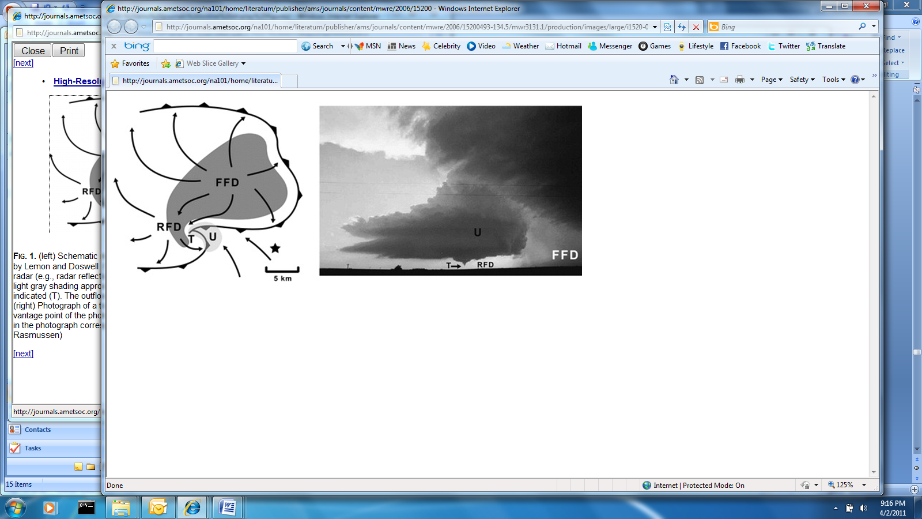

Figure 2. Schematic representation of a supercell thunderstorm, adapted from the conceptual model of Lemon and Doswell (1979).

The main downdraft location in a supercell occurs in the precipitation core below the cloud base. To the left of the downdraft schematic (Figure 2) are the rain-free cloud base and the flanking line of cumulus cloud towers, which are parallel with the gust front (Figures 2 and 3).

The updraft and the two downdrafts play an important role in the formation of a wall cloud, which is a rotating and large lowering of the cloud base. The formation of a wall cloud is due to the interaction between the warm updraft and the rain cooled downdraft producing additional cloud condensation. When this entrainment, warm updraft sweeping rain cooled downdraft, continue, the pressure decreases making the temperature drops and a cone-shaped column of fast rotating air extending from the base of the wall cloud, called a funnel cloud, forms. If the funnel cloud reaches the ground, it becomes a tornado.

Storm chaser observations have shown that the region behind the rear-flank downdraft contains almost no rain whereas the region down-wind from the main updraft has intense precipitation including both rain and hail; that region is also known to the storm chasers as the “bear’s cage” (Figure 3).

The region of heaviest rain and hail forms a distinctive hook-shaped Doppler radar pattern around the updraft, which is near the junction of the gust fronts. This hook region junction is the location where a tornado can form.

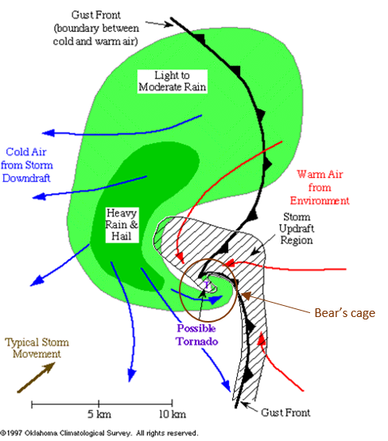

Figure 3. Schematic of surface conditions common with a supercell thunderstorm adapted from Lemon and Doswell (1979).

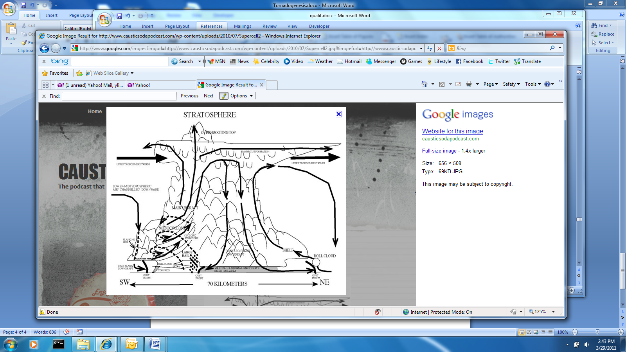

Figure 4. Schematic of inner structure of a supercell thunderstorm

Based on the thermal-wind relations, supercells form in regions with strong horizontal temperature gradients, i.e. near weather fronts.

*Helicity, H,* can be employed as a measure of the rotational magnitude of the updraft air in a storm, where

.

Davies-Jones (1984), and later Lilly (1986) showed that the helicity in a supercell thunderstorm reduces turbulent dissipation and thus prolongs the life of the storm. To measure the potential for tornadic supercell storms, a *storm-relative environmental helicity* (SHR) has been defined (Bluestein, 2007):

|  |  |
| --- | --- |
| $$SHR=-\int_{0}^{h}{\vec{k}∙\left(\vec{V}-\vec{c}\right)}×\frac{d\vec{V}}{dz}dz$$ | (3.7) |

where $\vec{V}$ is the environment wind factor, $\vec{c}$ is the storm motion vector, and h is an assumed storm inflow depth (usually taken to be 3 km AGL). SHR is a correlation between the vertical velocity and the vorticity (Droegemeier et al., 1993). The helicity and a strong wind shear, when combined, represents a good measure of the instability of the storm and is an indicator of the possibility of a tornadic storm (Davies and Johns, 1993).

Another parameter characterizing the atmospheric instability and the severity of a storm is called the *convective available potential energy*, CAPE (AWS 1961):

$$CAPE=g\int_{LFC}^{EL}{\frac{θ\left(z\right)-\overline{θ}\left(z\right)}{\overline{θ}\left(z\right)}}dz$$

where g is the acceleration of gravity, $θ\left(z\right)$ is the potential temperature of a moist air parcel lifted adiabatically, $\overline{θ}\left(z\right)$ is the vertical profile of potential temperature in the local environment, and EL and LFC are, respectively, the equilibrium and lifting condensation levels. Consequently, CAPE can be employed as a measure of the amount of energy that an air parcel would require in order to be lifted vertically in the atmosphere. When the CAPE value is high, the available lifting energy is high. This high energy favors storm growth, representing both an increase in updraft speeds and in overall power (energy), which tends to produce hail and tornadoes. The relationship between numerical values of the CAPE parameter and atmospheric stability is summarized in Table 1.

Table 1. CAPE chart (Thompson, 2006)

|  |  |
| --- | --- |
| **CAPE (J/kg)** | **Instability** |
| 0-1000 | Weak |
| 1000-2500 | Moderate |
| 2500-4000 | Strong |
| 4000+ | Extreme |

The maximum intensity of the updraft possible due to buoyancy forces is given by

$$w_{b}=\sqrt{2*CAPE}.$$

In most supercell storms, the updraft intensity is nominally equal to this theoretical maximum, due to buoyancy effects (Brooks, 1992)

## Sounding and its representation

Typically, vertical profile soundings of the atmospheric characteristics--temperature, dewpoint, wind speed and wind direction--are plotted on a Skew-T Log-P diagram (Air Weather Service, 1979). The sounding representation helps to visualize the “state” of the atmosphere such as the temperature profile, the moisture content, and local wind shear. From the temperature and dewpoint sounding data, cloud formation and/or precipitation can be determined. The diagram also permits characterization of the atmospheric stability condition (unstable, neutral, or stable). The wind speed and direction allows the visualization of the shear layer in the atmosphere, which helps in the determination of the potential for strong thunderstorm formation.

Figure 5, is a Skew-T Log-P diagram, with an embedded hodograph wind vector plot, from the 16-April 2011 weather event that will be the focus of this research. The red line represents the atmospheric temperature profile, starting from the surface level and the blue line represents the dewpoint profile. When the temperature and the dewpoint lines coincide, the air is saturated and the relative humidity is near 100%. The figure shows that the sounding and hodograph plots for the Raleigh, N.C., weather event exhibited relative humidity near 100% between the pressure altitudes of 900mb and 750mb.



Figure 5. Sounding and hodograph for Raleigh, N.C., weather event near the time when the outbreak occurred. Plot generated using the operational Numerical Weather Prediction data and reproduced from NOAA’s Rapid Update Cycle web site in real time.

The wind speeds and directions are represented using barbs pointing in the direction of the wind. The legend for the red barb symbols, employed in Figure 5, is displayed in Figure 6.

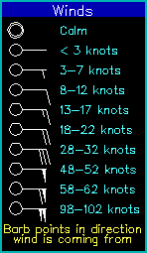

Figure 6. Legend of the wind barb points from Unisys website.

An alternate representation of the wind speed and direction utilizes a polar diagram (hodograph, Jon Davies, 1994), like the one shown in the upper left corner of figure 5. It is a vectorial representation of a moving particle, originating from a specific location. The hodograph helps to visualize the vertical wind shear and is a useful tool in predicting the evolution of a storm (Doswell, 1991).

## Description of Tornadoes

*Tornado* comes from the latin word “tornare”, meaning turn, and from the Spanish word for thunderstorm, “tronada”. Other names for that type of weather phenomenon are cyclone and twister. If a tornado forms above water, it is called waterspout. Like its name, a tornado is a violently-rotating column of air extending from the base of a thunderstorm cloud down to the ground. Tornado cores are usually less than 1.6 km in diameter and, unlike supercell thunderstorms, their typical lifetimes are on the order of 10 minutes (Bluestein, 2007). Because of their small size and relatively short life spans, it is difficult to fully document or understand their genesis and physics. Nowadays we are relying on the up-close observations of tornadoes and observations from Doppler radars and satellites.

Tornadoes sometimes form when the cloud base beneath the updraft on the rear side of the thunderstorm descends, forming a rotating wall cloud. As air continues to flow into the wall cloud, a rapidly rotating column of air can form below it. Initially, the rotating wind structure is not visible. However, as the local pressure near the rotational axis decreases, water vapor condenses while debris and dust are sucked into it, making it visible. As water vapor condenses in the air rushing up into the column, a funnel may form and reach the ground becoming a tornado. Once formed, nominal tornado timelines can usually be modeled with a life cycle consisting of the following four phases:

* Organizing: the funnel cloud picks up debris as it reaches the ground, then it widens.
* Mature: tornado strength and intensity peaks, with the funnel cloud reaching maximum width.
* Shrinking: the funnel narrows.
* Rope or decaying: the funnel cloud thins out to a very narrow column and then dissipates.

Although a significant fraction of tornadoes are associated with non-supercell convective storms (20%) and are called non-supercell tornadoes or *Type II Tornadoes* (Davies-Jones et al, 2001; Bluestein, 2007), the vast majority of strong to violent tornadoes are associated with supercell thunderstorms and are called *supercell tornadoes* or *Type I Tornadoes* (Davies-Jones et al, 2001; Bluestein, 2007).

Most tornadoes rotate cyclonically, but they can also be anticyclonic. Some tornadoes can also contain secondary-scale vortices within them that rotate about the main rotational axis (Figure 7). Those small-scale vortices are called *suction vortices* or *satellite vortices* or *secondary vortices*.

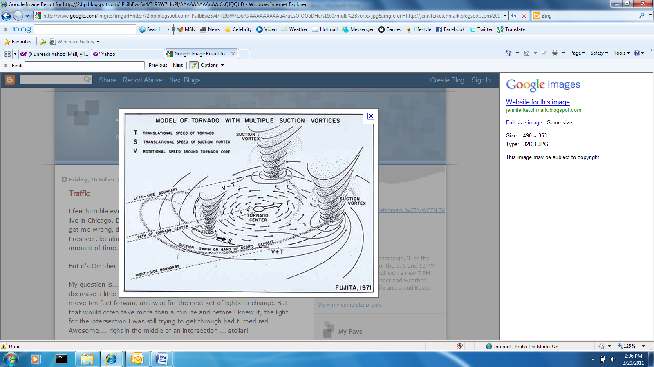

Figure 7. Tornado with multiple suction vortices.

In order to characterize the wind speeds in a tornado, Dr. Tetsuya Theodore Fujita (Fujita, 1971) created the Fujita scale in 1971, as a way to estimate maximum wind speeds *ex post facto*, based on the damage they caused (Fujita, 1971). The higher the Fujita number, on the scale from F0 to F5, the more severe the storm. However, in 2007, the Fujita scale was replaced by the Enhanced Fujita (EF) scale (Table 2) that is correlated to some extent with the Fujita scale (Wind Science and Engineering Center, 2006), but focuses more on quantifying the damage, rather than estimating maximum wind speeds. Tornadoes are not always reported because they can form and traverse unoccupied open spaces. Most tornadoes are weak (EF0-EF1); only 1% of US tornadoes are in the most violent and dangerous EF4 and EF5 categories. Recently, however, it seems that there are more EF4 and EF5 tornadoes occurring in the vicinity of populated areas.

Table 2. The Enhanced Fujita scale for tornadoes.

|  |  |  |  |  |
| --- | --- | --- | --- | --- |
| Category | Damage scale | Damage characteristics | Wind speed Range | |
| (km/hr) | (mph) |
| F0 | Light | Tree branches broken, heavy damage to crops, chimneys damaged. | 105-137 | 65-85 |
| F1 | Moderate | Trees uprooted, mobiles overturned, moving cars pushed off roads | 138-178 | 86-110 |
| F2 | Considerable | Large trees uprooted, mobiles destroyed, roofs torn off houses, railroad boxcars pushed off tracks | 179-218 | 111-135 |
| F3 | Severe | Most trees in a forest uprooted, walls torn off well-constructed frame houses, trains overturned, cars lifted off ground and moved | 219-266 | 136-165 |
| F4 | Devastating | Trees debarked by flying debris, well-constructed frame houses leveled, cars thrown some distance | 267-322 | 166-200 |
| F5 | Incredible | Strong frame houses lifted off foundations and demolished over some distance, steel-reinforced concrete structures badly damaged, cars flying | >322 | >200 |

Actual tornado cycles are being observed and reported by on-site storm-chasers. In addition, data from radars and satellites makes it possible to visualize the inner structure of these tornadic thunderstorms. As mentioned previously, the laser-Doppler radar pattern resulting from heavy rain inside a supercell generates a hook pattern, the so-called the *hook echo*, around the region most likely to produce a tornado. When radar beams reflect from this region, producing a hook echo pattern, it usually precipitates a tornado warning. With Doppler radar, the rapid change of the direction of the wind around a rapidly-rotating vortex can be detected.

## Tornadogenesis

A better understanding of the process of tornadogenesis is needed in order to predict or forecast tornado formation and strength. Due to the small diameters of most tornado cores, radar can only detect the parent circulation (mesocyclone) but not the tornado itself. Based on numerical simulations (Davies-Jones, 2008), the time interval between the formation of a radar-detectable hook echo and the subsequent formation of a tornado is short (5 t0 15 min); hence the lead time for initiating tornado warnings is in the range of 5 to 15min with a probability of detection of 63-75% (Bieringer and Ray, 1995). A key to perfecting our knowledge of tornado formation is to determine the mechanisms underlying tornadogenesis. However, our understanding of tornadogenesis is still incomplete. How is a tornado produced? Why do some supercell thunderstorms produce tornadoes while others do not? How and by what mechanism(s) is (are) a tornado(es) produced? Numerical simulations have been used to address those questions.

Early analyses (Barnes, 1970; Rotunno, 1981; Davies-Jones, 1984) showed that the vertical component of vorticity initially arises within thunderstorm updrafts as the result of tilting and subsequent stretching of the horizontal vorticity associated with mean vertical wind shear (Figure 8). This process is responsible for the formation of mid-level mesocyclones. According to Klemp and Rotunno (1983) and Rotunno and Klemp, (1985), the formation of low-level mesocyclones in a supercell is caused by the tilting of the baroclinic vorticity, induced by a horizontal buoyancy gradient along the forward-flank gust front. Because no strong baroclinicity in the forward-flank (FFD) zone was observed in experimental datasets (Shabbot and Markowski, 2006), we can conclude that the baroclinicity in the RFD is more important in explaining the rupture of vorticity lines. This hypothesis was later confirmed via numerical simulations (Rotunno and Klemp, 1985; and Alderman et. al, 1999). Shabbot and Markowski (2006) showed also that if there is baroclinic vorticity generation, the probability of tornadogenesis was high, but if this baroclinicity was too strong tornadogenesis was inhibited.

Figure 8. Tilting and stretching of the horizontal vorticity (Markowski et al.; 2009)

A cold air pool is also an important element in the generation of a tornado. A cold air pool is an area in the upper atmosphere where the air temperature is colder because the precipitation droplets have evaporated in the dryer air, producing heavier downdraft air that reaches the ground subsequently, spreading out horizontally (Engerer et al., 2008). Numerical simulations (Shabbot and Markowski, 2006) and meteorological measurements (Thompson et al., 2003) have shown that strong cold air pools are detrimental to tornado formation.

Because the mechanisms responsible for creating and sustaining tornadoes are not yet fully understood, more observational data, such as radar data, along with data from the VORTEX (Verification of the Origins of Rotation in Tornadoes Experiment, 1994-95) and VORTEX2 (2009-present) programs, is needed. Additional data can be used to validate and improve numerical simulations, helping to clarify the physical mechanisms. Important relevant observations (Markowski, 2002) confirm that, in close proximity to tornadoes, there are RFD and hook echoes. Hook echoes are useful passive indicators of possible tornado formation. It is also observed that there is no rain at the surface in the vicinity of an actual tornado. It is not known whether this is because the rain at the level of the tornado is subjected to the centrifugal effects due to strong rotation, or if it is because there is a clear rain-free zone. One theory for the formation of hook echoes is that they result from horizontal advection of precipitation in the associated mesocyclone.

Decoupling the tornado from its supercell thunderstorm host does not yield correct results (Fiedler, 1995). This is due to the fact that tornadogenesis requires participation by the parent storm. Therefore an appropriate computational domain has to be large enough to enable simulation of the complete storm. There are also inconsistencies between observations and numerical simulations that result from oversimplification of microphysical schemes. For example, rain is either produced prematurely and at too low an elevation (Straka and Ramussen, 1997) or the cold air pools are too large and cold (Gilmore et al., 2004) or the outburst of precipitation is too intense along the axes of developing tornadoes (Das, 1983). Those studies demonstrated that the microphysics is very important for high fidelity tornado simulations and simplifying the microphysics can be detrimental to the numerical simulations.

Davies-Jones (2008) showed that a rain curtain in a purely barotropic environment can enhance the updraft and downdraft interaction. This interaction can instigate the formation of a tornado. That study employed a two-dimensional simulation using what is now called the *Davies-Jones model*. Kis et al. (2008) performed and extended the same analysis in a three-dimensional simulation. They also showed that descending rain curtains enhance tornadogenesis and a specific range of rain mixing ratios was found to be essential for the downward angular momentum transport needed for tornedogenesis. Those simulations confirmed that thermodynamic characteristics of the angular momentum-transporting downdrafts, which are sensitive to low-level ambient relative humidity and precipitation characteristics of the rain curtain, control the intensity and longevity of tornadoes (Markowski et al., 2003).

Davies-Jones (2008) utilized an energy balance to show that the vertical component of kinetic energy decreases and the horizontal component of kinetic energy increases just prior to the formation of a tornado. This phenomenon could explain why the overshooting top of the supercell cloud collapses prior to the formation of a major tornado (Fujita, 1973, 1975). Therefore the energy created by water-phase-changes and the energy that is dissipated both into the cloud itself and into the environment are important research considerations that could help explain the increase in rotation of these vertical vortices.

In an effort to address the conflicting explanations for describing and predicting tornadogenesis, this dissertation will study an actual supercell storm that passed over Raleigh, NC on April 16th, 2011, and spawned several tornadoes. That storm traversed a geographical region that has numerous weather radars and government weather stations enabling detailed comparisons between recorded meteorological data and the numerical simulations.

# Description of the 16 April, 2011 Mid-Atlantic Frontal Storm and the Embedded Raleigh Tornado

On the afternoon of April 16th, 2011, a frontal storm containing multiple supercells developed and moved through the Carolinas and Virginia. At 20:03, UTC, a Doppler radar image of the extent of the North Carolina portion of the storm is shown in Figure 9, and Figure 10 is an enlarged image of the supercell formation (visible in the center of Figure 9) just prior to passing over Rayleigh, NC. From the National Weather Service report (National Weather Service. April 16, 2011), 30 confirmed tornadoes were produced as this storm traversed North Carolina and 11 confirmed tornadoes were produced subsequently over Virginia, causing significant damage and fatalities. One of the super cells produced a tornado that developed in Moore County in central South Carolina and moved northeast, striking Raleigh, NC and continuing into southeastern Virginia. That *Raleigh Tornado* will be the focus of this study. That particular tornado persisted for approximately 75 minutes (National Weather Service Eastern Region of North Carolina, 2011), producing a ground track approximately 100 km in length. At its peak strength, the estimated core diameter was 475 m. Assessment of the resulting damage was consistent with an EF-3 tornado severity rating.

The National Oceanic and Atmospheric Administration (NOAA) was able to predict the possibility of a tornado outbreak in the area around Raleigh, NC using numerical models that showed strong helicity and the associated extremely unstable atmosphere as was shown as an exemplar in Figure 5.

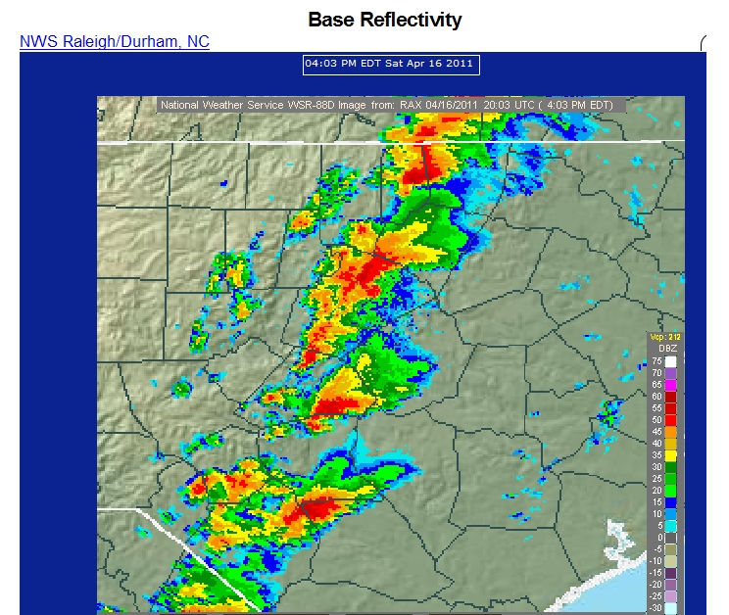

Figure 9. Series of supercells over North Carolina at 2003UTC, 16 April 2011

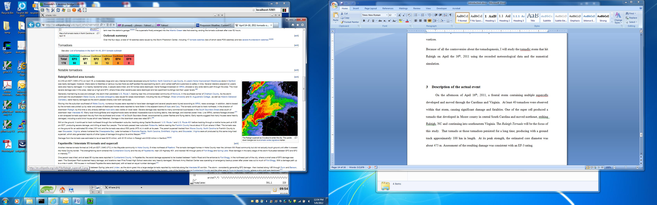

Figure 10. The Raleigh supercell just before encountering the city.

The purpose of the research is to attempt to isolate the meteorological parameters that are essential in the formation of a tornado. For this study, an actual storm that produced at least one tornado, preferably over a geographical area containing multiple weather stations and radars, was desired. The Raleigh storm selected for this study because Proctor et al (2012) had already simulated the event and were able to validate the underlying numerical simulation utilizing a suite of recorded observations of the event. Proctor et al. (2012) also conducted two other simulations with identical initialization conditions, except for the initial humidity levels in the atmosphere.

The first logical step for this study was to refine the grid spacing to increase the resolution in order to investigate further the three earlier simulations in more detail, attempting to resolve the vortex core structure (Bluestein, 2007) and quantify the inflow occurring in the supercell (Proctor, 1982). To control computational costs, while conducting the three more-detailed simulations utilizing a finer grid, a method was needed to reduce the computed domain without altering the dynamics of the storms. Furthermore, since the earlier, coarse-grid simulations captured some elements of tornadogenesis, it was necessary to validate any new refined grid simulations by demonstrating that the new simulations produced similar gross features before this study could be extended. Once the new methodology had demonstrated satisfactory comparisons with the earlier coarse-grid simulations, this study could proceed to provide further information about tornadogenesis.

# Numerical code

The Terminal Area Simulation System (TASS) is a large eddy simulation atmospheric flow model used to simulate convective storms, as well as local atmospheric disturbances, including aircraft trailing line vortices (Proctor, 1987). TASS was developed by Dr. Fred Proctor, starting in 1982, and has been maintained by that group up to the present (Proctor, 1986, Proctor, 1987, Switzer, 1996, Proctor, 2006, Ahmad, 2011). TASS is a compressible, non-Boussinesq code, enabling simulations to be valid, even in the presence of pressure deficits. The code computes time-dependent, non-hydrostatic difference equations within a three-dimensional domain. Cloud microphysics, such as water vapor, cloud droplets, ice crystals, rain, snow, hail, and their associated change of phase behavior are included using prognostic equations. The liquid and ice phases are modeled using microphysical parameterizations similar to Lin et al. (1983).

The pressure and momentum fields are discretized using quadratic-conservative, fourth-order finite-differences in space whereas the transport of potential temperature and water vapor computations employ the third-order Leonard scheme (1995). Water transport is simulated using the van Leer monotone upstream-centered scheme for conservation laws (MUSCL) (1979). An Arakawa C-grid was employed as the computational mesh for velocities and thermodynamics variables. The computational grid mesh is movable, translating with the simulated convection velocity. For the most part, TASS uses the Smagorinsky (1963) model for subgrid turbulence. However, in our simulations the Vreman (2004) model was employed due to its insensitivity to shear flow influences. Monin-Obukhov (1954) similarity theory was used to incorporate a surface friction layer at the computational base. In order to avoid excessive complexity, the surface boundary was assumed to be flat with uniform roughness. The Klemp-Wilhelmson (1978) time-splitting technique, which takes account of compressibility effects, was utilized in the present computations. Open inflow/outflow specifications for the lateral boundaries were defined using non-reflecting Orlanski (1976) boundary conditions.

TASS was written in FORTRAN and is maintained presently in fully parallelized FORTRAN for distributed computing platforms utilizing the Message Passing Interface (MPI). This interface allows TASS to run efficiently on parallel computer architecture. Indeed, per user specifications regarding the number of CPUs, TASS can split the global domain into smaller sub-domains (Switzer et al., 2014). Each CPU computes a share of the simulation. By using this MPI structure, large-grid simulations can be executable without overloading one single node, thus reducing computational time and cost. However even with up-to-date computers, there are still limitations related to the size of the computational domain and a balance has to be achieved between the simulation parameters and the time and cost to run the computations.

## Initial conditions

As mentioned, Proctor et al. (2012) used TASS to simulate the storm event of April 16th, 2011 near Raleigh, North Carolina. That study employed a computational domain that was 80 km x 80 km x 17.5 km, utilizing a grid spacing of 125 m x 125 m x 100 m. Three cases employing different moist environments were simulated. The earlier study showed that when the storm environment had higher moisture content, it produced more tornadoes than for storms within a dryer atmosphere.

The determination of the size of the domain and the grid spacing were critical for this research. Refining grids of this size increases the computational cost - both to generate the simulation and to post-process the results. In order to avoid unnecessary extra cost, the size of the original computational domain was reduced in order to utilize a finer localized grid and to capture with higher fidelity the storm dynamics at simulation times prior to the formation of the first tornado. Since Fiedler (1995) has shown that decoupling the tornado from its supercell thunderstorm host produces incorrect results, the overall size of the domain had to be large enough to contain the storm itself, in order to avoid erroneous results. Noda et al. (2003) demonstrated that the overall grid extent was critical. The grid spacing plays an important role in the behavior and evolution of the simulated storm. Hence, grid spacing has to be small enough to capture the characteristics of the storm. Other parameters, such as the size of the vortex cores, have to be taken into account. Indeed, Bluestein (2007) observed from radar data that typical vortex core radii are 100 to 200m. Moreover a 100 m vertical spacing is barely enough to resolve the inflow in a supercell containing a tornado (Proctor, 1982). It was necessary to balance the computational cost with the overall research purpose in this study. Considering the critical parameters just discussed, a new model computational domain was developed with overall dimensions of 40 km x 40 km x 17.5 km, and with grid element spacing of 62.5 m x 62.5m x 50 m, satisfying the requirement to reproduce as accurately possible the dynamics and behavior of a supercell storm. In other words, there are 321 x 321 x 375 = 38,640,375 grid points. The domain was considered to be large enough to contain the storms simulated by Proctor et al. (2012), and the horizontal grid spacing of 62.5m could capture the vortex cores.

To initiate the simulation of a supercell, a sounding profile has needed. This profile will have to satisfy three important parameters. First the environment has to be instable. CAPE variable measures the instability. Second, the air has to be warm and moist in the lower troposphere, in other words between the pressure levels 1000 hPa and 900 hPa. The third parameter is a moderate to strong vertical wind shear. Figure 11 represents a typical sounding of the supercell environment: a high CAPE, warm moist air in the lower troposphere, a dry cool air in the middle troposphere (pressure levels between 900 hPa and 250 hPa), and a strong wind shear. Gilmore et al (1998) showed that for supercell storms with identical CAPE characteristics, the local atmospheric humidity in the mid-tropospheric altitude interval plays a role in controlling the intensity and evolution of the storm. Relative dryness affects the downdraft; when the atmosphere is drier, the vertical wind magnitude and scale are reduced, whereas when the atmosphere is more humid, the vertical wind state is enhanced. In this study, the input of environmental humidity will be the only change in the initialization of the simulations, in order to make the atmosphere either similar to Raleigh sounding (Figure 5) or moister or dryer. Therefore the dry cool air showed on Figure 11 will be either diminished or intensified. The area in Figure 11 marked by the horizontal red stripes represents the area bounded by the temperature sounding and the projected temperature path of the lifted air parcel and is defined as a positive area, representative of a positive buoyant energy condition. The positive area represents the instability of the atmosphere. That positive buoyant energy is needed to sustain thunderstorms. For the three sounding this area is positive.

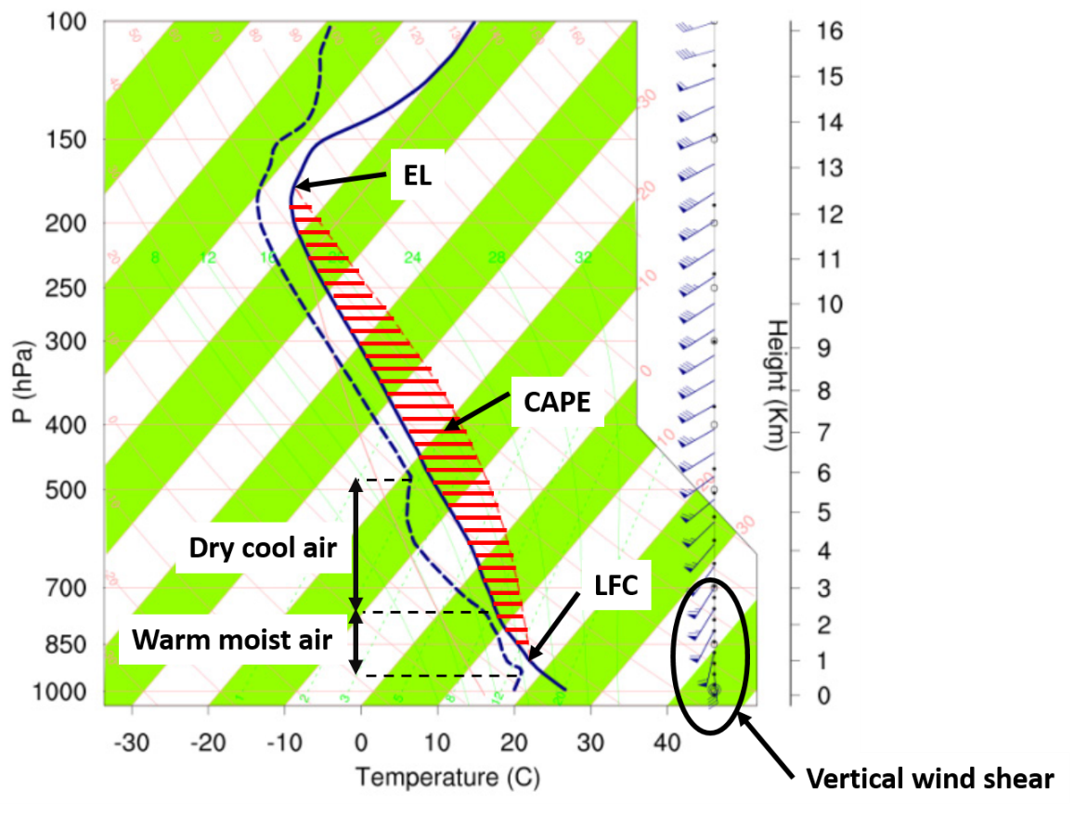

Figure 11. Sounding description in a supercell environment

Three of the Proctor et al. (2012) simulation cases - the reference storm and wet and dry extreme cases - have been re-examined, utilizing this refined grid, and simulated subsequently in this study. By refining the grid for each case, it should be possible to capture the important characteristics describing tornadogenesis. The three simulations developed in this study were conducted following the same procedures as the previous study; as stated previously, the only difference was the input of the environmental humidity. Figures 12, 13, and 14 represent the imposed soundings for the three cases simulated in this study. The vertical axis on the left is the associated local ambient pressure, corresponding to the geometric altitude axis, on the right of each graph. The first case utilized the actual sounding data; the second case imposed a deeper, more-humid environment than the actual event and the third case employed a dryer environment above 2000m. All three cases assumed that the 100 % relative humidity, condensation level was at 842m elevation above sea level. The initial conditions for localized temperature and moisture content were obtained from actual soundings taken prior to and in the vicinity of the tornado occurrence.

Figure 12 represents the initial conditions for localized temperature and moisture content obtained from actual soundings taken prior to and in the vicinity of the tornado occurrence. This sounding was based from the original sounding of Raleigh (Figure 5) but slightly modified to satisfy the surface measurements reported near Raleigh. The sounding profile for the wet case (Figure 13) differs from the actual case sounding only by the fact that the dry air between the altitudes of 2.5 km and 6 km, or equivalently between the pressure levels of 710 hPa and 430 hPa, has been reduced to get a deep moist environment. In the dry case (Figure 14), the dry airmass has been intensified between the altitudes 2.5km and 12 km, or equivalently between the 710 hPa to 180 hPa, pressure interval, and it is represented by the substantial separation between the dewpoint and temperature profiles.



Figure 12. Skew-T diagram representing the sounding for the reference case. Solid line represents the sensible temperature and the dashed line the dewpoint temperature.



Figure 13. Skew-T diagram representing the sounding for the wet case. Solid line represents the sensible temperature and the dashed line the dewpoint temperature.



Figure 14. Skew-T diagram representing the sounding for the dry case. Solid line represents the sensible temperature and the dashed line the dewpoint temperature.

## Pre-processing

### Reduction of the domain

Reducing the size of the domain and refining the grid spacing in order to help to capture more details without changing the form of the storms was also a crucial part of this research. The important part of maintaining the supercell structure is the updraft, which feeds the storm with moisture and drives the downdrafts. The warm air of the updraft is ahead of the gust front. Therefore, it is important to include the environment in front of the storm into the reduced domain.

The new boundaries of the domain were determined using the location of the original simulated storm and are represented on Figure 15.

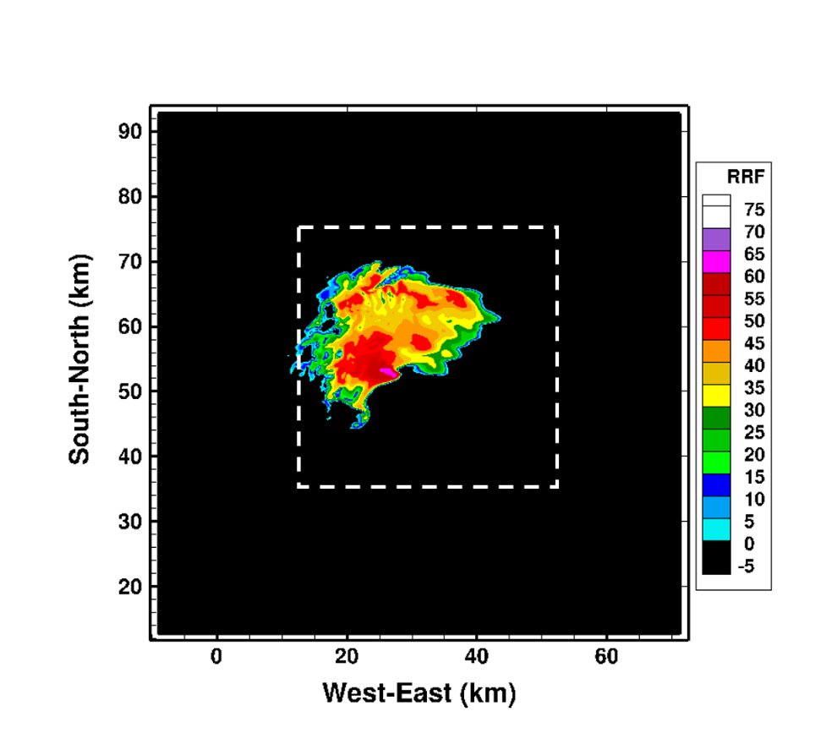

Figure 15. Refine grid boundaries for the wet case. The original grid was cut on the white dotted lines.

The conditions imposed on the new grid were:

* The new boundaries had to capture the formed storm completely.
* The right (Eastern) boundary must not be too close to the gust front to avoid disruption of the storm dynamics.
* The lower (Southern) boundary must be separated far enough from the hook region of the storm to minimize perturbations.

### Initialization

The 80 km x 80 km x 17.5 km Proctor et al (2012) grid and simulation was analyzed initially in order to establish a nominal simulation time interval that would result in the formation of a mesocyclone and the first tornado – those simulation times are summarized in Table 3. The post-processed data, including pressure and velocity fields, were simulated every 30 seconds and all three cases were examined individually in developing simulation interval specifications. As shown in Table 3, the moist atmosphere simulation was more favorable for producing tornadoes. Indeed, the wet simulation case generated a mesocyclone four minutes before the other two cases. For that wet case, seven minutes after the formation of the mesocyclone, a tornado formed, compared with a 15 minute interval for the reference case, while no tornadoes were formed for the dry case.

Table 3. Simulated storm characteristics

|  |  |  |
| --- | --- | --- |
| **Case** | **Time from the formation of the mesocyclone** | **Time of the first tornado formation** |
| Reference | 0:49 | 1:04 |
| Wet | 0:45 | 0:52 |
| Dry | 0:49 | No tornado |

Based on the earlier simulation study, restart files were written at simulated 20 minute intervals. The purpose of the restart files was to enable the simulations to advance over appropriate overall simulation times without restarting from the beginning. As mentioned earlier, the simulations employing the refined grid could not be started from the beginning due to excessive computational costs. A better option was to select specific restart file intervals at times when all the mechanisms known to drive the simulated storms were in place. Three restart options were considered—(1) 20 minutes, (2) 40 minutes or (3) 60 minutes. Option 3 was not a good option for any of the three cases. Indeed, for the wet case the tornado was formed before the 60-minute restart time. In the reference case, it was observed that only four minutes elapsed before initiation of tornado formation, and the sequence of events responsible for tornadogenesis had probably advanced too far at that point to permit any sort of systematic isolation of sequential events. For the dry case, no tornado was formed so any restart had to be from an earlier time than option 3, in order to understand why no tornadic event occurred. First, the 20-minute restart files were selected for all three cases. The goal of the research was to reproduce the previously-simulated storms from Proctor et al (2012), but utilizing a smaller domain with a finer grid to capture more details related to tornadogenesis. To verify this choice, simulations for the three cases using the 20-minute restart files were run. The only difference with the original simulations was the size of the domain; in the new computations, the computational domain was smaller. The grid spacing was the same for both cases. The new small-domain simulation results did not agree with the results obtained by Proctor et al (2012).

An investigation was initiated to determine why the results from the smaller domain were unacceptable, and a reexamination of the original simulations utilizing those restart files showed that the simulated storms had not formed completely after a 20-minute simulation. The conclusion was that by creating a restart file too early in the simulation of the storm formation (Figure 14) and restricting simultaneously the computational domain, the surrounding environment was decoupled from the evolving supercell storm. This decoupling impacted the mechanisms contributing to the evolution and strength of the simulated storms. This finding agreed with the conclusions of Fiedler (1995) and Lewellen (2000). Hence, the 20-minute restart strategy was deemed unacceptable for the present research, and a 40-minute simulation restart strategy was determined to be the only available option that was capable of reproducing the original simulated storms. As in option 1, the simulations using 40-minute restart files for all the three cases were executed, in order to demonstrate that the new, reduced-domain simulations could replicate the results obtained by Proctor et al (2012). That conclusion was reached when the computational domain size was reduced but the grid spacing was unchanged, and the results duplicated the Proctor et al (2012) results. As shown in Table 4, the mesocyclone formed at the same time as the reference case, but it formed one minute later for the wet case. Using the restart files from the original simulations for which the storms were already well formed (Figure 16), and reducing the size of the domain did not affect the evolution and local behavior of the supercell storm. Therefore the 40-minute restart strategy was selected to proceed to the next step of the research: grid refinement of the computational domain.

Table 4. Comparison between the original and the reduced domain size of the imulated storm characteristics

|  |  |  |  |
| --- | --- | --- | --- |
| **Case** | **Time from the formation of the mesocyclone** | **Equivalent Time from original simulation** | **Difference** |
| Reference | 0:09 | 0:49 | 0 |
| Wet | 0:05 | 0:45 | 0 |
| Dry | 0:10 | 0.50 | 1 min later |

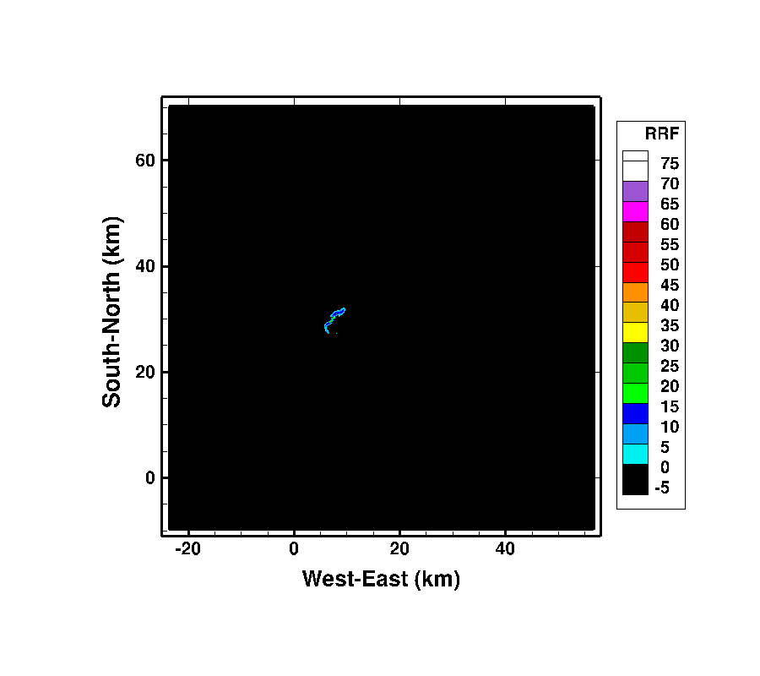

Figure 16. Simulated Radar Reflectivity at 1000 m altitude at 20 min for the reference case.

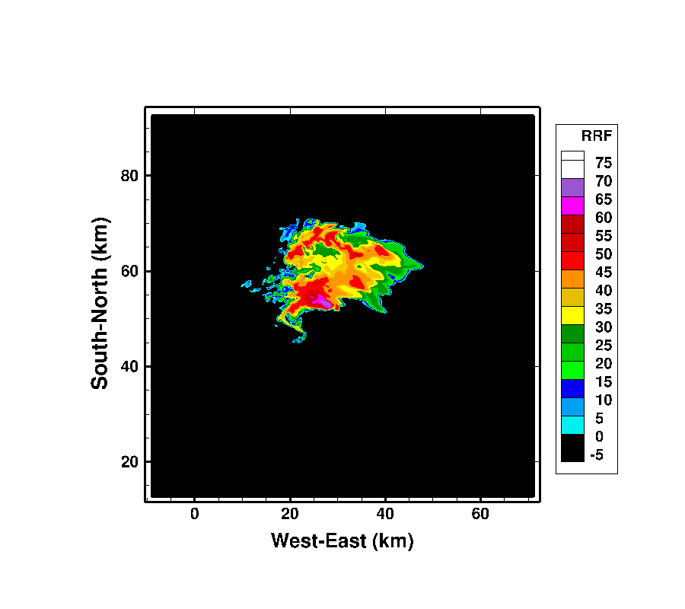

Figure 17. Simulated Radar Reflectivity at 1000 m altitude at 40 min for the reference case.

During the refinement of the domain, in order to not modify the gross structure and behavior of the simulated storms, the first priority was to conserve the original boundary conditions-based definition of the domain. The original ground boundary condition is non-slip with a parameterization for surface stress based on Monin-Obukhov similarity theory. The surface boundary is assumed to be flat with a uniform surface roughness, z0, set to 30 cm. The lateral boundaries, South-North and West-East, are open/outflow. The top boundary has a closed/free-slip condition.

To perform the refinement, TASS software already incorporates two pre-processing codes, intended to refine the actual grid and extrapolate the different variables using a restart file. For this study, it was necessary to modify the TASS grid refinement scheme. The original computer code utilized inputs that defined the static dimensions of the grid and required a specified refining ratio. Modifications were required to enable the user to incorporate and specify moving grid boundaries. Resizing of the domain was only utilized in the lateral directions. Therefore, the top and bottom-surface boundaries were not a concern and were conserved during the process of resizing. The open lateral boundaries allow the flow to leave the domain without reflection and should not pose any issues when downsizing the domain.

To verify the correctness of these modifications the TASS code was run using only the moving grid modification, with a refining ratio of 1, meaning there was no refinement. Those simulations demonstrated that there weren’t any inconsistencies associated with the moving grid. However, when the moving grid modifications were tested with a specified grid refinement ratio of 2, it was found that the grid cutting and refining method and/or technique did not perform properly. Indeed when performing the interpolation, the subroutine computing the variables at the new boundaries was issuing an error about arrays out-of-bound. In other words, the pre-processing code, which interpolates the original TASS data, was not designed and coded to redefine the boundaries and to interpolate the data simultaneously.

Based on an in-depth study of the original code and the modified code, a two-step strategy was developed. The new code was modified to proceed by first resizing the computational domain utilizing a reduced overall size and then refining the grid spacing for this reduced domain. Using the restart file approach, new South-North and West-East boundaries were defined and the variables for this new domain were extrapolated from the previous data set. The TASS code was tested with this new cut-restart file and that simulation was compared with the initial uncut solution, in order to validate the two-step methodology. For the three cases, using the solution files extracted from the original simulations at the time of the restart file (40 min) and from the new simulations at the initial time (0 min), Table 5 is a comparison of the maximum values of the radar reflectivity (RRF) and the range of simulated pressures inside the computational domain. Comparing the results between the simulation using the grid employed by Proctor et al (2012) and the simulation using the resized grid, no appreciable differences were observed in the radar reflectivity maximum values, as well as the minimum and maximum values of simulated pressure. This comparison demonstrated that the simulated storm features were not altered during the process of resizing the computational domain. There were slight differences between the average values for the radar reflectivity and pressure, due to the fact that the aft portion of the storm was lost during the convection process (Figure 18). When comparing the interpolated results of the simulations using the resized grid and the refined grid, the differences were observed to be less than 5%.

Table 5. RRF and pressure comparisons between original, resized, and refined grids

|  |  |  |  |  |
| --- | --- | --- | --- | --- |
|  | | RRF (dBz) | Pressure (mb) | |
| Max | Min | Max |
| Reference | Original grid | 71.2 | -10.68 | 1.66 |
| Resized grid | 71.2 | -10.68 | 1.66 |
| Refined grid | 72.2 | -11.22 | 1.74 |
| Wet | Original grid | 74.2 | -7.66 | 1.80 |
| Resized grid | 74.2 | -7.66 | 1.80 |
| Refined grid | 74.4 | -7.93 | 1.89 |
| Dry | Original grid | 67.6 | -5.92 | 1.38 |
| Resized grid | 67.6 | -5.92 | 1.38 |
| Refined grid | 68.4 | -6.18 | 1.44 |

Figure 18 is a simulated radar reflectivity pattern at 400 m, corresponding with the conditions observed for the actual Raleigh case. Figure 18 (a) was produced using the TASS output file written at the same simulation time as the restart file selected to generate the new grid and to extrapolate the variables. Figure 18 (b) represents the storm in the cut, non-refined domain. The South-North and West-East axes differ because the pre-processing code redefined the axes with respect to the center of the storm, where the wind was maximum. Figure 18 (c) represents the simulated radar reflectivity pattern for the storm after refining the grid. Figure 18 (b) is a zoomed in version of Figure 18 (a) and shows that the process of resizing the domain did not modify the storm. Figure 18 (b) and Figure 18 (c) are quasi-similar with small differences due primarily to the interpolation method. One such differences is highlighted on Figure 19. Figure 19 represents the radar reflectivity at 400m for the reference case. Figure 19 (a) represents the solution for the non-refined grid whereas Figure 19 (b) represents the simulation solution for the finest grid. The two plots showed that the storms are similar in shape and rain intensity. However, in some locations in the storms there are differences, as pointed in Figure 19. The differences are due to the interpolation routine.

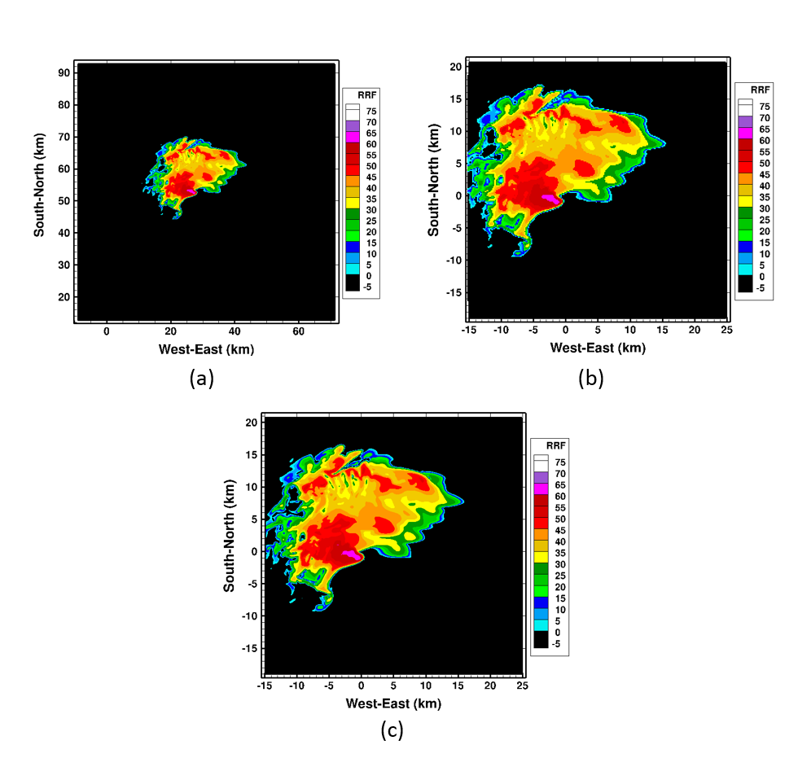

Figure 18. Simulated Radar Reflectivity at 400m, from left to right, for (a) the reference case with the original grid at 40 min of original simulation, (b) the cut grid, and (c) the refined grid at 0 min of the new simulations.

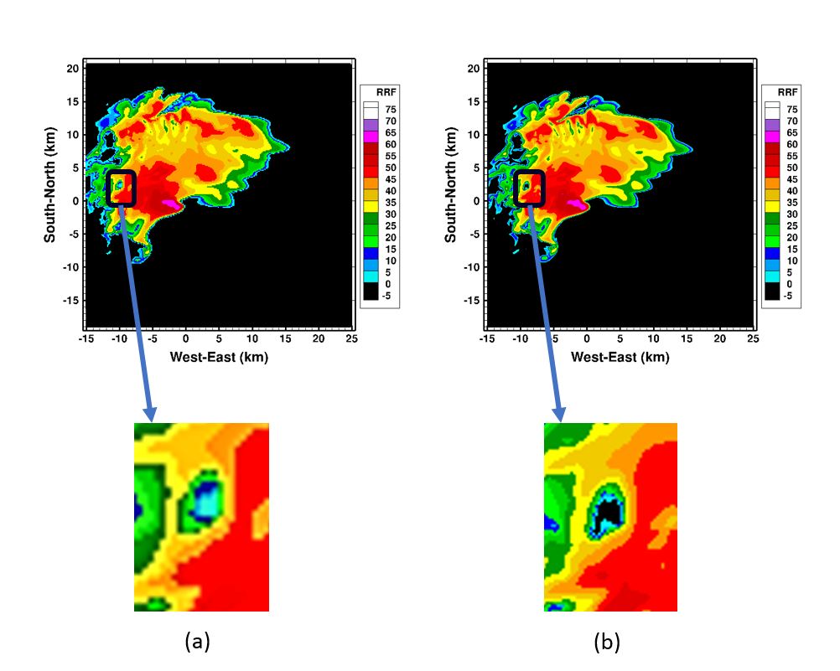

Figure 19. Zoom on a difference between solutions using resized domain (a) and refined domain (b).

## Post-processing

Once the simulations were run, it was necessary to extract the information required for interpretation of this research. After generating the new grid incorporating the data from the 40-minute restart file for all the three cases, TASS was run for 20 min of simulation outputting a graph file every 30 seconds. In other words 41 graph files per simulation were generated. The size of each graph file was 17.3 Gbytes and was a three-dimensional data field, made up of 29 variables at each location, including the coordinates. Those graph files were too massive to be post-processed directly to analyze and visualize the solutions. Hence, due to the quantity of data and file sizes, a very efficient file processing procedure was required. The post-process procedure allowed selection of the variables desired for this study, in order to reduce the size of the data files into more manageable sizes.

One of the TASS post-processing codes is called *Tecmz*, written in FORTRAN. That code extracts the numerical values of the variables for each graph file generated during the simulations. The output files can either be stored in Excel or Tecplot formats. The Tecplot format was selected for this research because the simulations have been performed in a UNIX environment. Other reasons to use Tecplot was that Tecplot can manage bigger files than Excel, and was numerous tool to better visualize the flow field data. Now the size of the solution files are approximately 300 Mbytes. The Perl programming language was selected for this study. Perl is an interpreted programming language, which does not require compilation, enabling direct implementation. Perl coding is derived from the C language, but also utilizes features from the shell programming, which makes use of the UNIX commands. Perl language was ideal for processing and manipulating the large data files produced by these simulations. The Perl codes, also called scripts, are more compact and permit linkages with other systems and interfaces. It was on the basis of these characteristics that Perl was selected for the simulation post-processing study. Two main Perl scripts were written and run to post-process and then visualize the data. The first script extracted the data from the TASS output files by running the executable for Tecmz. The second script enabled visualization of the results by running Tecplot. The scripts helped increase the overall simulation efficiency by automating the post-processing process. Figure 20 represents the flowchart of the TASS solution post-processing.

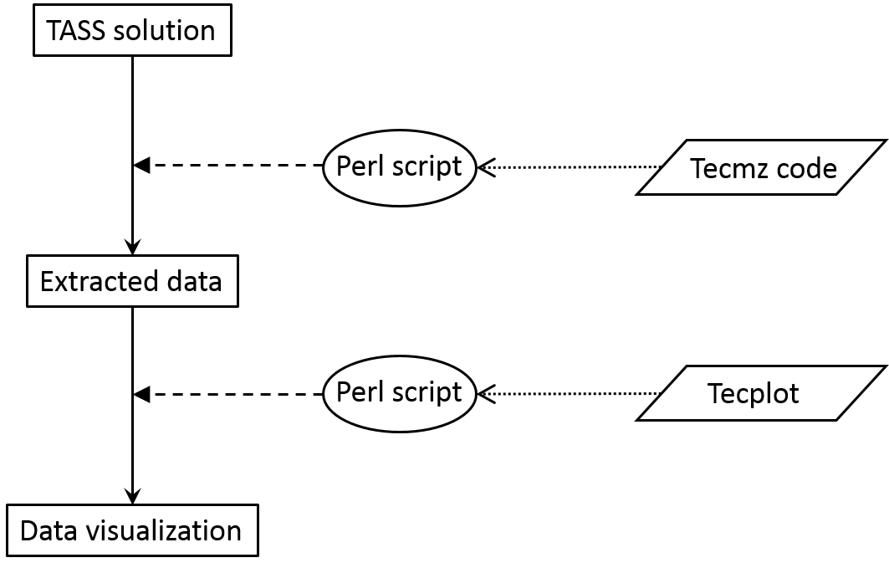

Figure 20. Post-processing flowchart

This research also developed a FORTRAN code, which allows users to follow the trajectories of imaginary, massless particles released in the “air” at arbitrary locations inside the computational domain. Those massless particles have been called “air particles”. Using the outputs of the velocity components (u, v, and w) extracted from the TASS over the simulation time and written in the Tecmz output files, the particle paths for these air particles were generated and written onto a Tecplot format.

To obtain a better visualization of particle paths in the simulated storm region, the vertical domain was partitioned into five zones. The zone layers were 0-1km, 1-5km, 5-10km, 10-15km, and above 15km. Those bounding altitudes were selected based on the origins of the two downdrafts, 3-5km and 7-10 km AGL, the origin of the updraft, 3-5 km AGL, and the altitude of the mesocyclone formation (7-10 km AGL) (Leslie et al., 1979). The strong storm-relative helicity at altitudes below 1km AGL is associated with a tornadic supercell (Markowski et al., 2003). The overshooting top is usually located at the equilibrium level height, which is near 12 km AGL, but depending on the strength of the updraft the equilibrium level height can vary between 11 and 15 km AGL (Thompson et al., 2007).

After each 30-second time step, all the particles are displaced by several meters at least. Therefore if there was no discrimination regarding particle selection, the user would not be able to identify storm features, as shown in Figure 21. For this reason, it was necessary to specify which particles were desired for a particular visualization. The mean wind speed in a supercell is primarily between 8 and 20 m/s depending on the altitude (Kerr et al., 1996). Based on the mean wind speed and to create the best visualizations of particle motion, after multiple tries, it was determined that the particles had to travel at least 4 times the horizontal grid spacing over a simulation time interval of 30 seconds. In others words the particle had to travel 4*62.5 = 250 m in 30 seconds, which is equivalent to a speed of 8.33 m/sec. Other parameters had to be considered, such as the size of the domain. Each particle that was followed required storage of a path history. If all the particles at each node were being followed, during the first time step, 38,640,375 particles would need to be followed. That amount of data was not manageable and the visualization was too difficult. Instead after multiple tries, it was found that by selecting every 4 grid points as the initial locations of the particle set, satisfactory results were produced (Figure 22).

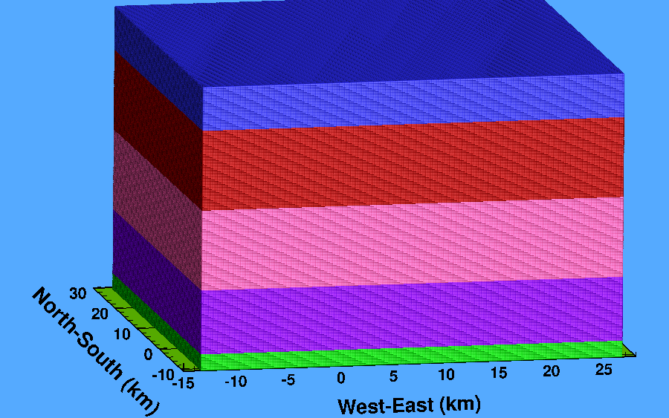

Figure 21. Particle representation with no discrimination regarding the particle selection

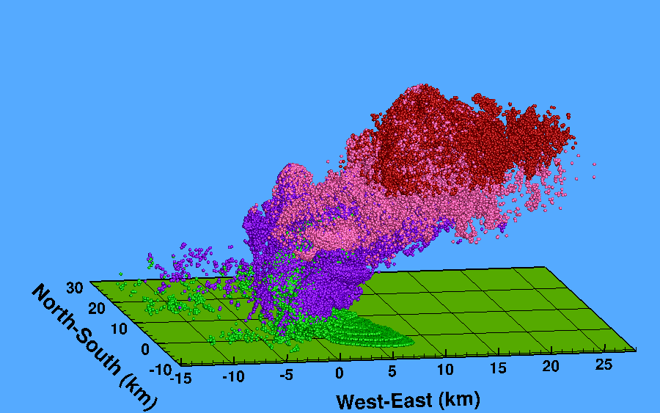

Figure 22. Particle representation with discrimination of particle motion

Table 6. Summary of the particles being followed

|  |  |  |  |  |  |  |
| --- | --- | --- | --- | --- | --- | --- |
| **Case** | **Average number of active particles followed per zone** | | | | | **Total of particles followed** |
| **0-1 km** | **1-5 km** | **5-10 km** | **10-15 km** | **> 15 km** |
| Reference | 53,094.2 | 115,461.7 | 168,782.1 | 47,859 | 0.45 | 34,164,505 |
| Wet | 64,446.45 | 171,391.4 | 287,979.8 | 93,849.45 | 1,272.35 | 34,892,127 |
| Dry | 24,725.05 | 41,473.9 | 17,421.85 | 4,698.1 | 0.2 | 31,239,996 |

# Results of the simulations

This section presents the results of the three simulations.

## Domain size importance

During this study, it was demonstrated that the computational domain had to be large enough to simulate an overall storm. Indeed, if the computed storm was initialized in a horizontal domain area that was too small, in this case, a fixed 40 km x 40 km, the resulting storm simulation was smaller, weaker, and did not produce the same quantities of rain. The smaller simulation region did not represent adequately the reference storm.

Figure 23 demonstrates the need to utilize initially a substantially larger computational domain, even if it utilizes a coarse grid, in order to permit the use of a smaller, moving grid. Figure 23 shows, at equivalent computation time, the simulated radar reflectivity at 400 m, for the original simulation with the original grid (80 km x 80 km) (Figure 23 (a)), the simulation using the smaller grid (40 km x 40 km) initialized with the sounding data, but without the 40-minute, CFD-conditioning restart file, generated from the original simulation (Figure 23 (b)), and the simulation using the smaller grid (40 km x 40 km) initialized with the sounding data and with the conditioning restart file (Figure 23 (c)). When comparing the three simulated storms at an equivalent computation time, it was determined that the simulation represented by Figure 23 (b) failed to reproduce the size and strength of the reference storm. It was also observed that at a later time, when the reference storm had formed and was producing tornadoes, as reproduced utilizing the 80 km x 80 km footprint storm, the unconditioned small-grid storm simulation had nearly dissipated. Those results showed that the size of the computational domain coupled with the initialization of the simulation is primordial. Indeed the supercell simulation is sensitive to the size of the computational domain combined with the method of the initialization. Utilization of a smaller, moving computational domain is only possible when those simulations are conditioned using a restart file, that contains data of a fully-develop storm generated by a larger-domain simulation. The restart file is necessary, in order to properly impose the inflow and outflow conditions associated with the larger storm. In that way, as the domain move forward, the appropriate boundary specifications are maintained. Combining a too small domain with only the vertical sounding of the atmosphere as a starting point of the simulation affects the mechanisms of the supercell storm. Not only the tornado cannot be decoupled from its supercell storm (Fiedler, 1995) but when the supercell storm is at its early age of formation, it cannot be decoupled from its environment, or else the storm is losing its intensity.

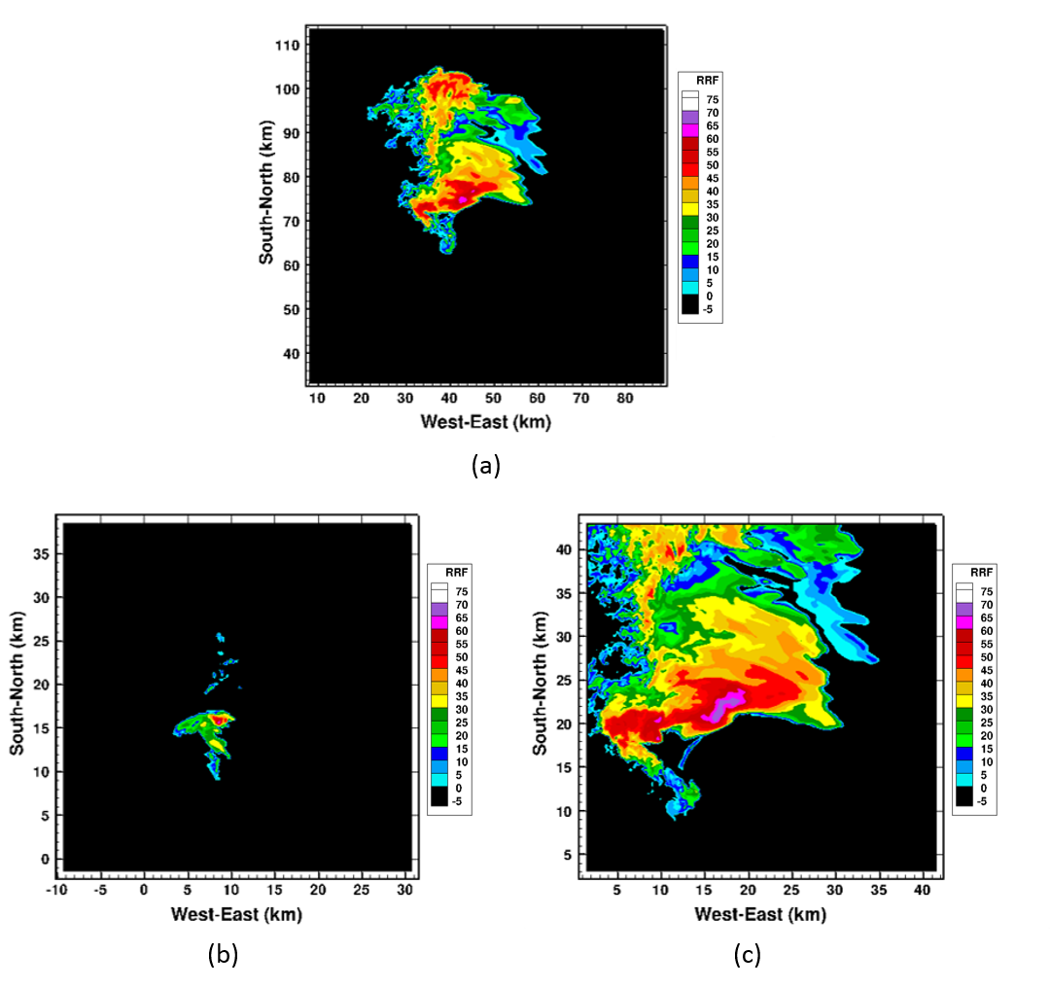

Figure 23. Radar reflectivity results showing the importance of the computational domain for (a) the original simulation, (b) the simulation for a 40 km x 40 km grid and initialized with the sounding data, but without the restart file, and (c) the simulation for a 40 km x 40 km grid and initialized with the restart file.

Comparing the radar reflectivity for the three refined simulations versus the original ones (Figure 24, Figure 25, and Figure 26), it can be seen that the storm simulations preserved the same gross characteristic shapes, and strengths as the reference storm, but provided more detail.

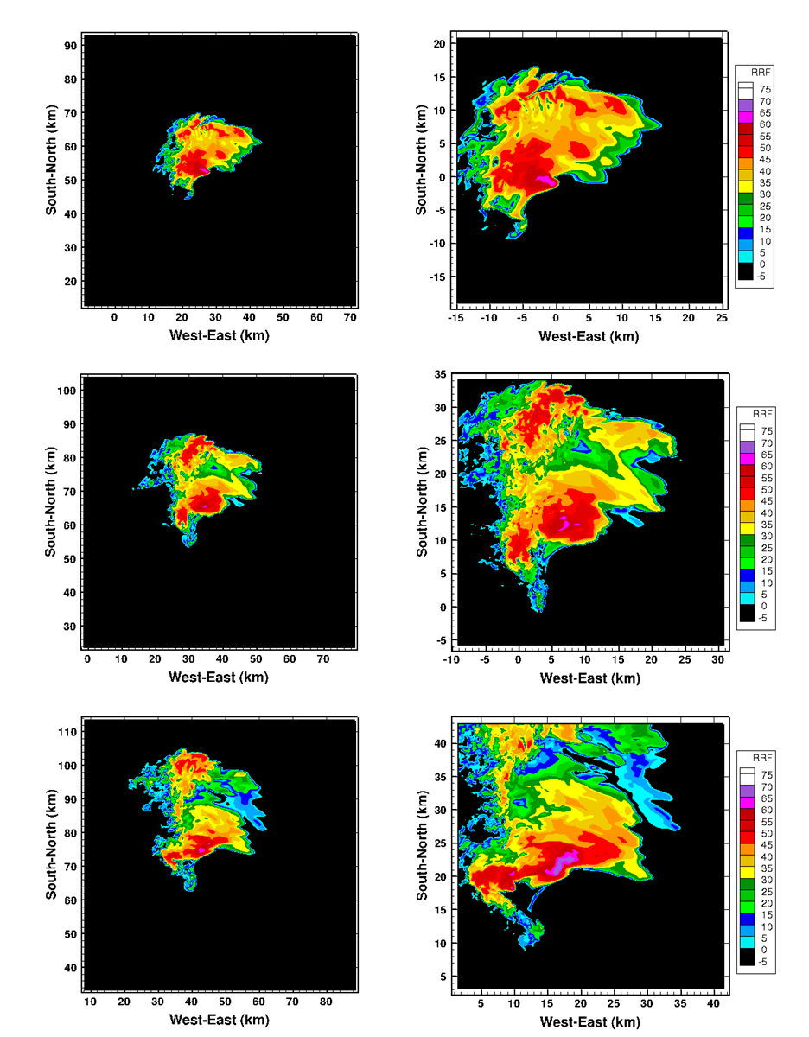

Figure 24. Radar Reflectivity for the reference case at an elevation of 400m above the ground. The original grid is represented on the left and the refined grid on the right. From top to bottom, the times are t=40min, t=50min, and t=60min for the original simulation and t=0, t=10min, t=20min for the new simulation.

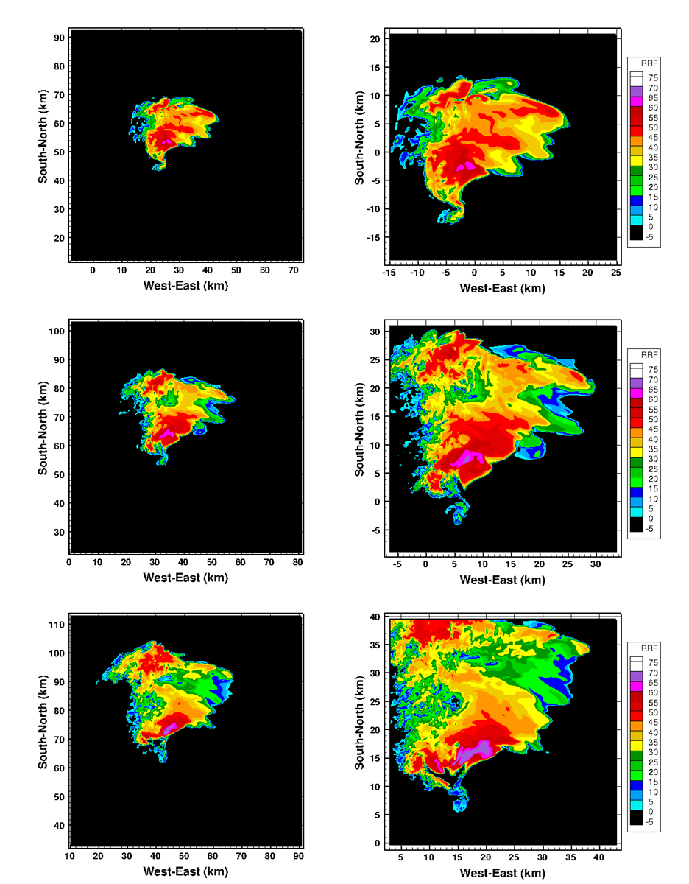

Figure 25. Radar Reflectivity for the wet case at an elevation of 400m above the ground. The original grid is represented on the left and the refined grid on the right. From top to bottom, the times are t=40min, t=50min, and t=60min for the original simulation and t=0, t=10min, t=20min for the new simulation.

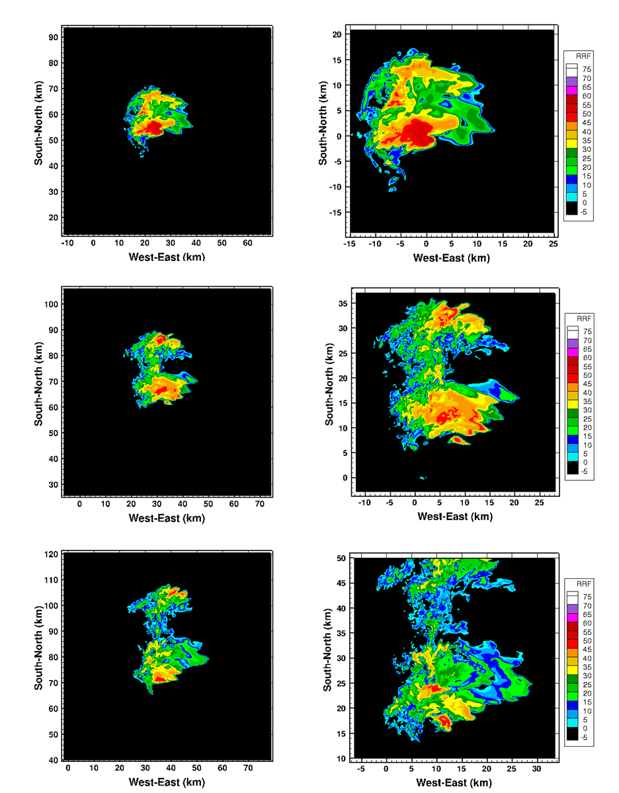

Figure 26. Radar Reflectivity for the dry case at an elevation of 400m above the ground. The original grid is represented on the left and the refined grid on the right. From top to bottom, the times are t=40min, t=50min, and t=60min for the original simulation and t=0, t=10min, t=20min for the new simulation.

## General results

For the most part, the three simulated storms resembled the observed Raleigh storm. Table 7 synthesizes some of those characteristics.

Table 7. Comparison of TASS results with observation

|  |  |  |  |  |
| --- | --- | --- | --- | --- |
| **Case** | **Storm speed (m/s)** | **Direction (°)** | **Mesocyclone** | **Tornedo producer** |
| Observed | 23 | 230 | Yes | Yes |
| Reference | 22 | 220 | Yes | Yes |
| Wet | 22 | 220 | Yes | Yes |
| Dry | 25 | 210 | Yes | No |

From the previous studies, summarized in Table 7, this research showed that the dryer atmosphere simulation case did not produce tornadoes, while the reference case produced some, and the wet case produced a larger number. The results of the refined simulations confirmed many of the results from Proctor et al (2012), such as the storms are moving from the Southwest direction, and they all have a radar hook echo and mesocyclones. However, one of the differences was that the dry case did not produce overshooting storm tops, which is a dome-like protrusion at the top of the cloud. An examination of the diverse parameters that resulted in the three substantially-different simulation cases follows.

### Pressure

Table 8 summarizes the minimum and the maximum pressures, the surface pressure and the storm pressure, for the three simulation cases. Clearly we can see that for the wet case the minimum surface pressure and the maximum storm pressure have larger amplitudes than for the two other cases.

Table 8. Minimum and Maximum Pressure at the surface and in the domainfor the three cases.

|  |  |  |  |  |
| --- | --- | --- | --- | --- |
| Case | Surface Pressure (mb) | | Storm Pressure (mb) | |
| min | max | min | max |
| Reference | -8.4 | 1.3 | -18.9 | 2.8 |
| Wet | -27.2 | 2.8 | -27.6 | 3.1 |
| Dry | -5.9 | 3.5 | -13.3 | 3.5 |

Figure 27 shows that the maximum surface pressure histories (dashed lines in the figure) are quasi-steady and almost identical for all three cases. The maximum surface pressure does not appear to play a role in the formation of tornados. However, the simulated minimum surface pressure histories are distinctly different for the three cases. Figure 27 indicates that tornado formation occurs for the reference and wet cases when large surface pressure deficits are present. The minimum surface pressure for the dry case (solid blue line) did not fall below -5.9 mb and was not as low as the other two simulation cases. However, the dry case did exhibit a small pressure collapse early on, after 4 min, 8 min and 10 min of the simulation. The minimum pressure for the reference case is almost constant except for the depression with a sudden surface pressure collapse of about 3 mb occurring 12 minutes into the simulation. The surface pressure for the wet case (solid green line) exhibits the most extreme negative pressure fluctuations with very large amplitudes, such as 17 mb at 10 min, 27 mb at 18.5 min and 19 mb at 18 min of the simulation.

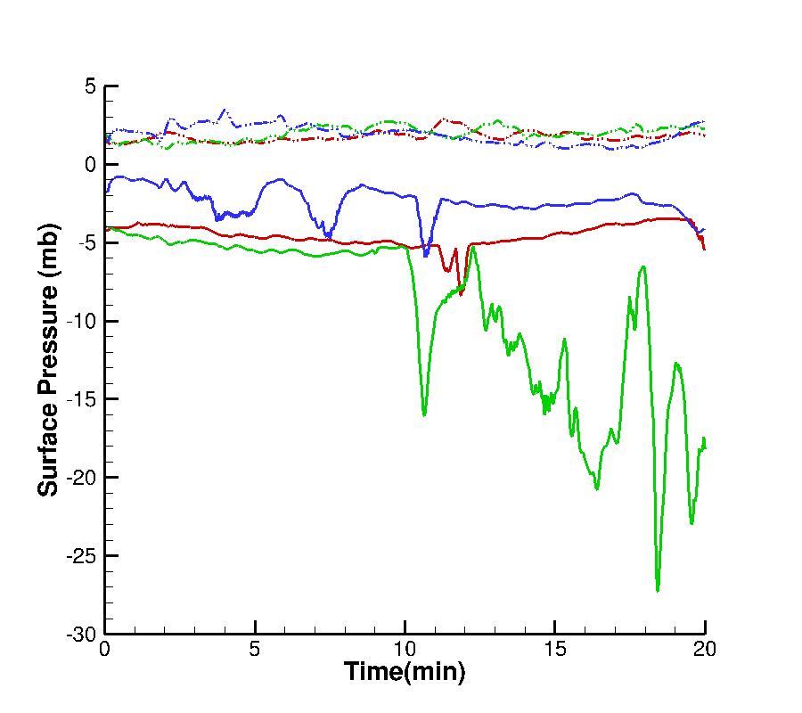

Figure 27. Surface Pressure History. Red line represents the reference case, green the wet case, and blue the dry case. The solid lines are the minimum pressure and the dashed lines are the maximum pressure at the surface.

Figure 28 shows the minimum and maximum pressure inside the domain. The maximum pressure (dashed lines in figure) are quasi-steady and almost identical for the three cases, as was the case for the maximum surface pressure shown previously. The maximum pressure in the storms does not appear to play a role in the formation of the tornado. However the minimum pressure inside the domain is very distinctive for the three cases. The minimum pressure for the dry case (solid blue line in figure) seems to collapse progressively from about -6 mb to -13 mb in 7 minutes and then the minimum pressure for the dry case rises progressively toward the -6 mb level, with only two small (4 mb) depressions observed before stabilization at the end of the simulation. The minimum pressure for the reference case (plain red line) shows a similar progressive collapse behavior to the dry case, except for the two stronger depressions at 13 min and at the end of the simulation. The minimum pressure for the reference case is also lower overall than the dry case. The minimum pressure for the wet case (solid green line) exhibits more fluctuations beginning at mid-simulation. The main collapse is also more accentuated, from -13 mb to -28 mb. Additional details concerning the pressure minima observed in the three cases will be discussed later.

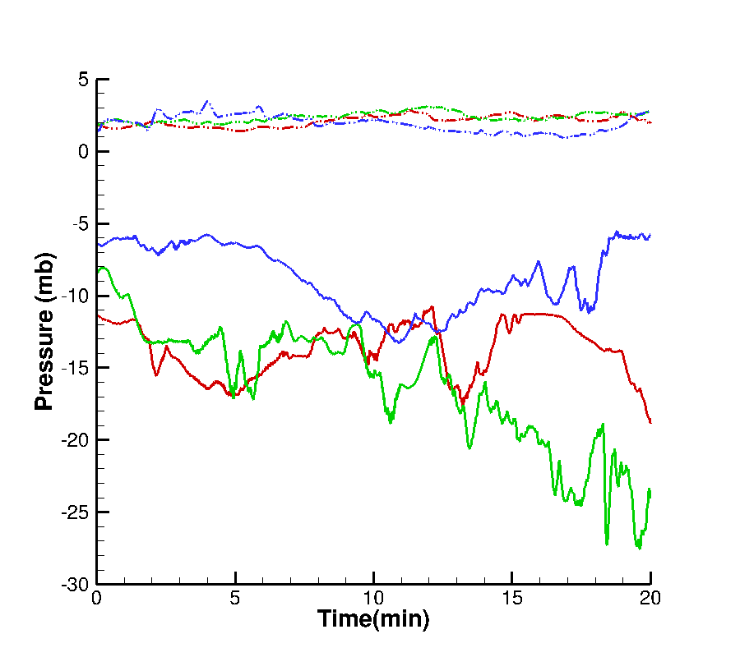

Figure 28. Minimum and Maximum Pressure History inside the domain. Red line represents the reference case, green the wet case, and blue the dry case. The solid lines are the minimum pressure and the dashed lines are the maximum pressure

Figure 29 represents the minimum pressure over the simulation times and altitudes. It is showing that the minimum pressure for the dry case (Figure 29 c) does not exhibit any large depressions. Figure 29 shows that there are small "pockets" of significant pressure depression for the reference case. Those pockets correspond to the simulation times where the local pressure minima, as shown in Figure 28, occur (i.e. 5 min, 13.5 min, and 20 min). This same pressure behavior applies also to the wet case (Figure 29 b) which is indicative of a physical process. Indeed Figure 29 b shows that the pressure depression pockets are numerous and are situated at mid-simulation times associated with the minima as observed previously.

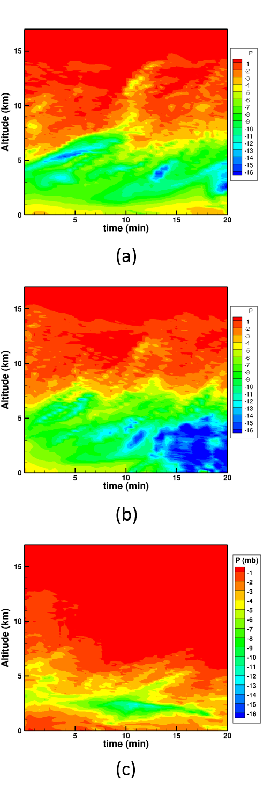

Figure 29. Minimum pressure over the simulation times and altitude. (a) reference case, (b) wet case, and (c) dry case.

Previously, pressure minima were observed for the three cases. In the reference case the three main pressure depressions occurred at nominal simulation times of 5 min, 13.5 min and 20 min. Those peaks are identified in Figure 30. The simulation lasted for 20 min, and the third depression occurred at that time. Therefore, the actual minimum pressure may not have been simulated. Indeed in Proctor and al. (2012), a tornado was formed in the reference case 1 hour 4 min into the initial simulation, which in this study would occur after a 24 min simulation time. For those three times, Table 9 is a summary of the strength of the depression and the location and altitude relative to the computational domain. At each subsequent pressure minimum, the pressure depression is getting stronger and closer to the surface. Figure 31 displays the 8 mb pressure deficit zone relative to the cloud for the reference case at the three specific simulation times, i.e. 5 min, 13.5 min and 20 min. At t = 5 min, the storm appears to be organizing, but no mesocyclone has formed. At 13.5 min the mesocyclone has formed. At last, at 20 min of simulation, a funnel appears to be outlined.

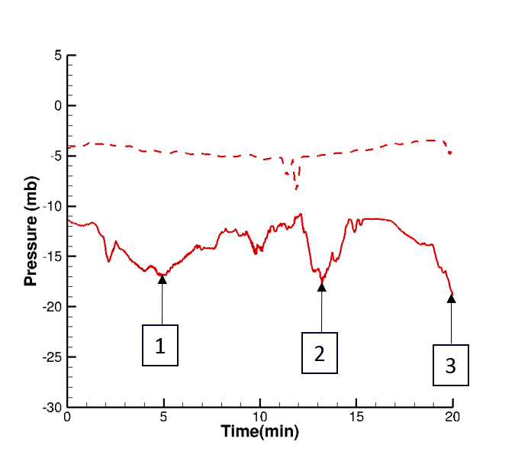

Figure 30. Minimum Pressure History inside the domain for the reference case. The red plain line represents the domain pressure, and the red dash line the surface pressure.

Table 9. Location of the pressure peak occurrence relative to the domain for the reference case.

|  |  |  |  |  |  |
| --- | --- | --- | --- | --- | --- |
| Peak | Pressure (mb) | Simulation time (min) | West-East Location (km) | South-North Location (km) | Altitude (km) |
| 1 | -16.9 | 5.0 | 2.5 | 1.6 | 5.5 |
| 2 | -17.6 | 13.5 | 8.1 | 8.4 | 3.7 |
| 3 | -18.8 | 20.0 | 13.7 | 15.9 | 2.6 |

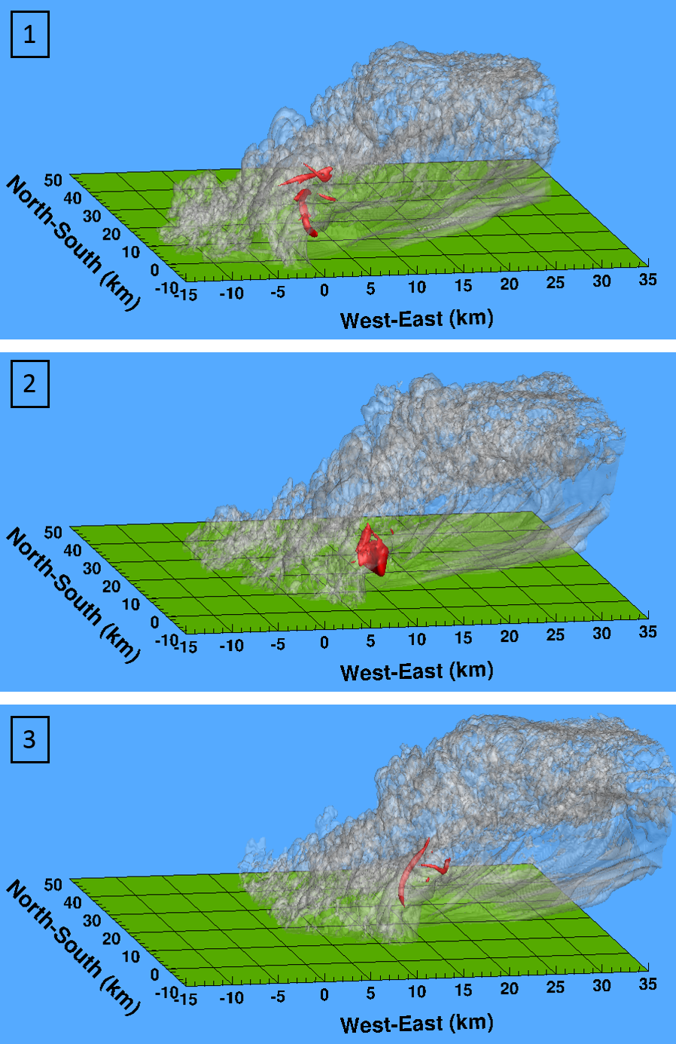

Figure 31. 8 mb pressure deficit and cloud prespective for the reference case at t = 5min (1), 13.5 min (2), and 20 min (3) of the simulation.

For the wet case the three main pressure depressions occurred at 5.5 min, 10.5 min and 18.5 min of the simulation. Those depressions are identified in Figure 32. Compared with the reference case, the domain pressure at the occurrence of the first and second depressions are almost the same magnitudes. From about 18.25 min and 18.75 min, the green plain and dash lines are superimposing which identifies the fact the domain pressure minima is the same than the surface pressure minima at this period of the simulation. For those three times of the pressure depressions, Table 10 summarized the strength of the depression and the location and altitude relative to the domain. At each pressure minimum, the pressure depression is getting larger and closer to the surface, particularly at 18.5 min. Figure 33 represents the 8 mb pressure deficit relative to the cloud for all the three times of the simulation, i.e. 5.5 min, 10.5 min and 18.5 min. As the reference case, at 5.5 min the storm seems to still be in a phase of organization but already with a small-scale mesocyclone. At 10.5 min, the wet case pressure deficit is similar to the 13.5 min one in the reference case. Then a tornado was formed at 18.5 min..

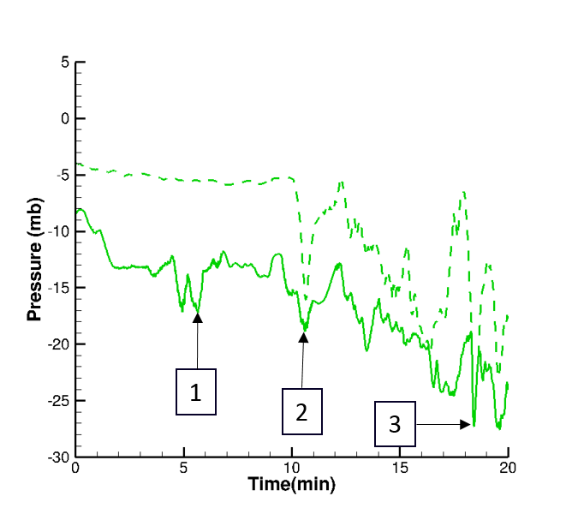

Figure 32. Minimum Pressure History inside the domain for the wet case. The green plain line represents the domain pressure, and the green dash line the surface pressure.

Table 10. Location of the pressure peak occurrence relative to the domain for the wet case.

|  |  |  |  |  |  |
| --- | --- | --- | --- | --- | --- |
| Peak | Pressure (mb) | Simulation time (min) | West-East Location (km) | North-South Location (km) | Altitude (km) |
| 1 | -17.1 | 5.5 | 3.7 | -2.6 | 3.8 |
| 2 | -18.7 | 10.5 | 9.1 | 0.9 | 4.3 |
| 3 | -27.2 | 18.5 | 14.3 | 5.9 | 0.1 |

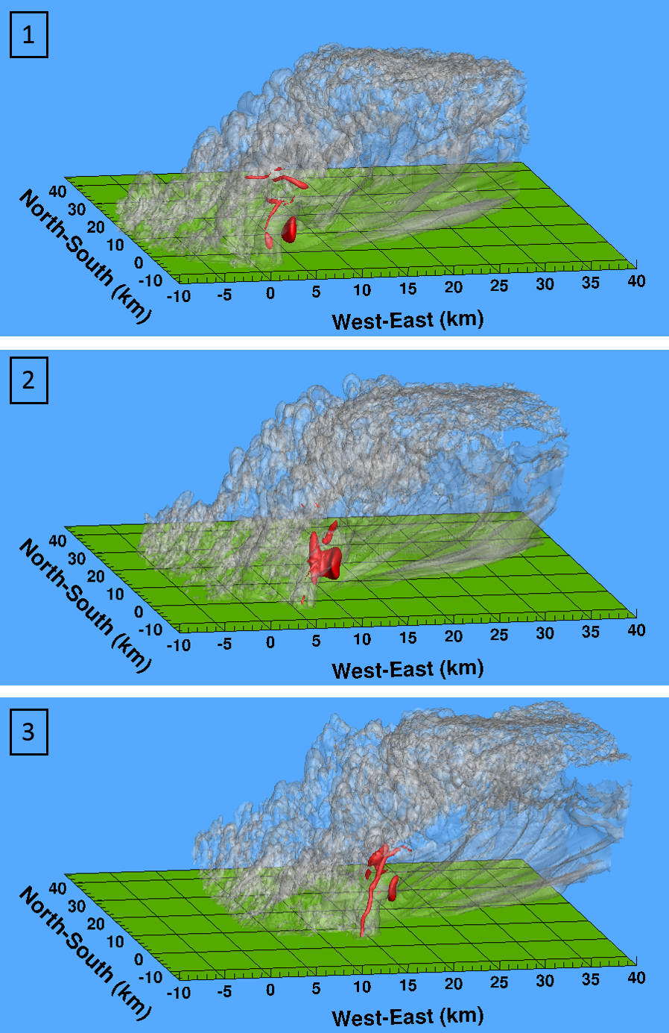

Figure 33. 8 mb pressure deficit and cloud prespective for the wet case at t = 5min (1), 10.5 min (2), and 18.5 min (3) of the simulation.

For the dry case the three main pressure depressions are occurring at 11 min, 16.5 min and 17.5 min of the simulation. Those depressions are identified in Figure 34. Compared to the reference and wet cases, those depressions are not as prominent. For those three times, Table 11 summarized the strengths of those depressions and the location and altitude relative to the domain. Even if the altitude of the location of the pressure minima is getting closer to the surface, the pressure depressions are not getting stronger. Figure 35 represents the 3 mb pressure deficit relative to the cloud for all the three times of the simulation, i.e. 11 min, 16.5 min and 17.5 min. For this case to be able to visualize the pressure deficit, a 3 mb pressure deficit threshold was used instead of the 8 mb, which was chosen for the reference and wet case. Again the storm seems to try to organize but the pressure differences are not sufficient when compared to the reference and wet cases. At 16.5 min and 17.5 min, the mesocyclone may have formed but is small and weak.

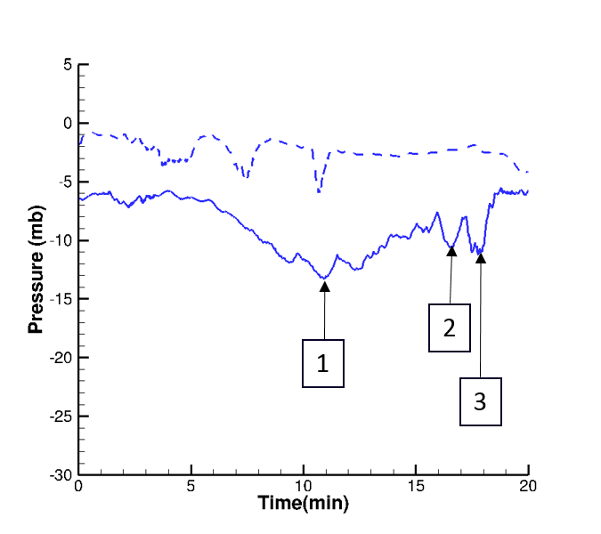

Figure 34. Minimum Pressure History inside the domain for the dry case. The blue plain line represents the domain pressure, and the blue dash line the surface pressure.

Table 11. Location of the pressure peak occurrence relative to the domain for the dry case.

|  |  |  |  |  |  |
| --- | --- | --- | --- | --- | --- |
| Peak | Pressure (mb) | Simulation time (min) | West-East Location (km) | North-South Location (km) | Altitude (km) |
| 1 | -13.2 | 11.0 | 1.0 | 9.0 | 4.8 |
| 2 | -10.6 | 16.5 | 4.3 | 15.2 | 2.0 |
| 3 | -11.2 | 17.5 | 4.9 | 16.7 | 1.7 |

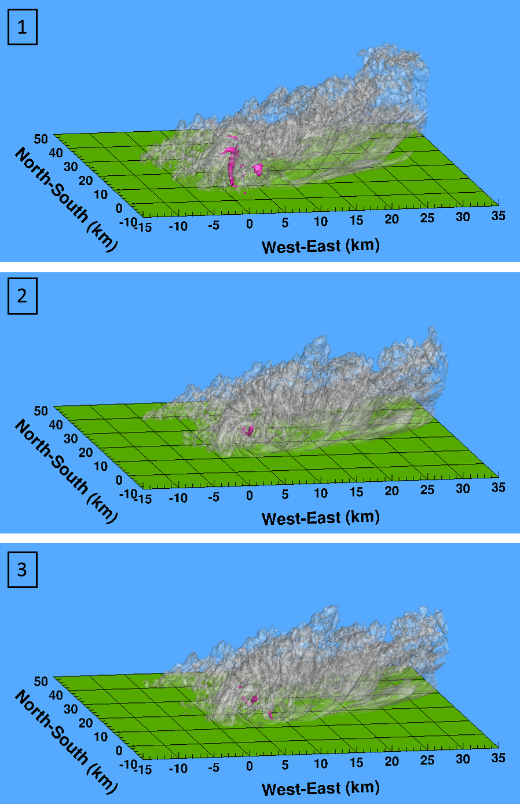

Figure 35. 3 mb pressure deficit and cloud prespective for the dry case at t = 11 min (1), 16.5 min (2), and 17.5 min (3) of the simulation.

The pressure, its behavior and strength, appears to be a primordial element in the formation and evolution of tornadic supercells or their non-formation. From the section of this thesis, Tornadogenesis, researchers showed that the vertical velocity, aka downdraft and updraft, plays also important role to the tornadogenesis.

### Vertical Velocity Behavior

The span of the local vertical component of velocity within the computational domain is an important gage of storm intensity. The maximum updraft velocities for the three moisture states (dashed lines) and maximum downdraft velocity (plain lines) values are shown in Figure 36. The downdraft velocities (minimum vertical velocity values), are quasi-steady for all three cases and can be seen to fluctuate between -20 and -40 m/s. The downdraft intensity for the dry case (plain blue line) is slightly weaker than the downdrafts for the two other cases. Consequently, the minimum vertical velocity does not appear to play a major role in tornadogenesis. The maximum vertical velocities, which represent the maximum updrafts of the storm, are also quasi-steady for all the cases. The updraft for the dry case (dashed blue line) fluctuates between 20 and 40 m/s and is weaker than the updrafts for the reference case (dashed red line) and the wet case (dashed green line). The updrafts for the reference and wet cases exhibit very similar transient behavior, with fluctuations between 40 and 65 m/s. Another observed difference is the rather smooth appearance of the updraft velocity for the dry case, and its gradual decay behavior rather than the more-rapid (almost jagged) fluctuations and gradual growth of the upwelling velocities for the reference and wet cases.

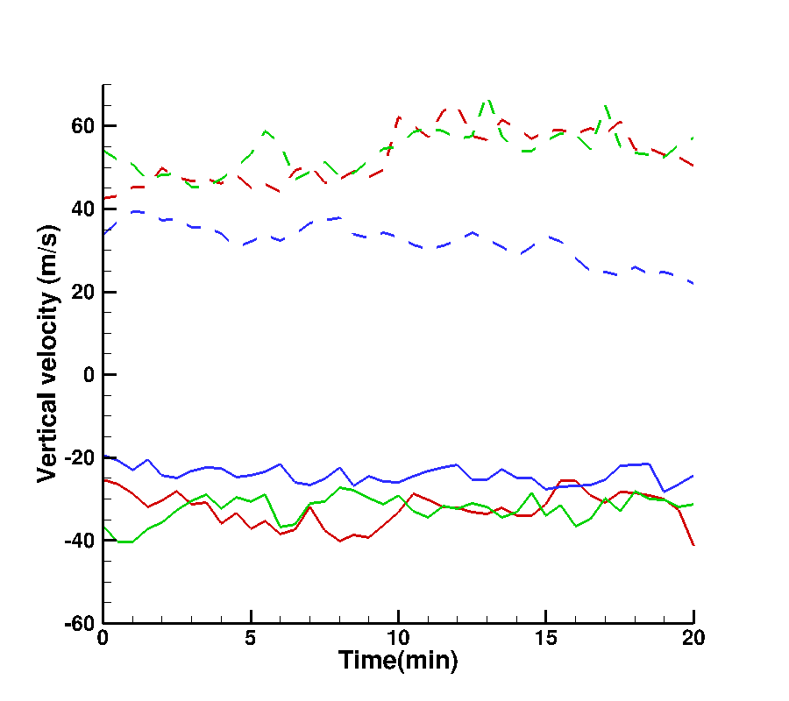

Figure 36. Minimum and Maximum Vertical Velovity History inside the domain. Red line represents the reference case, green the wet case, and blue the dry case. The solid lines are the minimum velocity and the dashed lines are the maximum velocity.

Table 12 summarizes the maximum and minimum for the downdraft and updraft velocities for the three cases spanning the complete simulation histories. The maximum downdraft velocity over the domain and time is about the same for the three cases. The minimum downdraft velocity is similar for the wet and dry cases. The minimum downdraft for the reference case, occurred after 20 min, when the third minima of the pressure depression was occurring during the simulation. Clearly, we can see that for the reference and wet cases the minimum and maximum updraft velocities are similar. The values also demonstrate that they are stronger than the updraft observed for the dry case, where the maximum updraft velocity corresponds to the updraft minima of the reference and wet cases.

Table 12. Minimum and Maximum of the downdrafts and updrafts in the domain for the three cases.

|  |  |  |  |  |
| --- | --- | --- | --- | --- |
| Case | Downdraft Velocity (m/s) | | Maximum Updraft Velocity (m/s) | |
| min | max | min | max |
| Reference | -47.5 | -18.9 | 44.0 | 73.8 |
| Wet | -38.8 | -18.5 | 46.0 | 75.1 |
| Dry | -33.7 | -19.6 | 22.2 | 41.8 |

Figure 37 represents the time-height cross section of the updraft (left side) and downdraft (right side) velocities for the three cases. These plots reveal additional characteristics of the simulated storms. First, a large difference in the updraft and downdraft velocity in the dry simulation case (Figure 37 c), in comparison with the reference case (Figure 37 a) and the wet case (Figure 37 b). Indeed for the dry case, the updraft and downdraft velocities are weaker, and there are no significant updraft and downdraft cores. There is no updraft or downdraft above 13 km of altitude. The updraft is hardly existent above an altitude of 7 km, continuing from 7 min. into the simulation and continuing through the end. Similarly, the downdraft is virtually unobservable above 7 km, starting from 11 min into the simulation and continuing until the end. On the other hand, for the reference and wet cases, there are numerous updraft cores in the altitudes interval between 2 and 14 km. In the reference case, there are two major updrafts. The first one is observed between 9 and 14 km above the surface, starting 10 minutes into the simulation and lasting for about 3 minutes. The other major updraft is not as strong but its lifetime is twice as long, and it extends from 3 to 12 km. Moreover, the reference case has a major downdraft core, which lasts for 7 minutes and is located between 5 and 8 km. That case also has numerous downdraft cores formed between 12 and 14 km. For the wet case, the updraft seems to be slightly stronger near the surface and is present in the upper atmosphere (> 15 km) within the first 5 minutes of the simulation. In this case there are three major updrafts but they are not as extensive as the updrafts simulated in the reference case. The first updraft core for the wet case occurred between 9.5 and 13 km, starting at 12 minutes into the simulation and lasting for about 2 minutes. The other two updraft cores were below 5 km starting, respectively, at 8.5 min and 13.5 min into the simulation, and lasting less than 4 minutes. The wet case had no major downdraft cores but has multiple small-scale cores mostly contained between 5 and 8 km and between 12 and 14 km. .

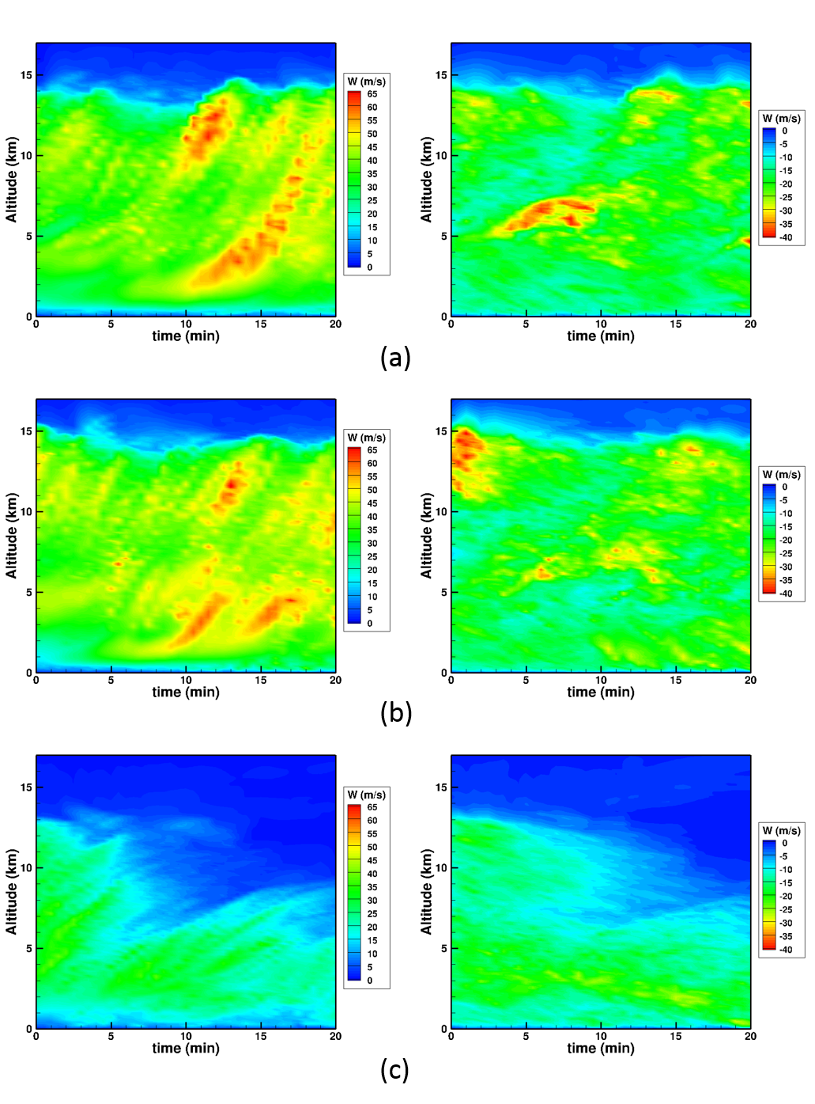

Figure 37. Maximum and minimum velocity over the simulation times and altitude. (a) reference case, (b) wet case, and (c) dry case.

Figure 38, Figure 39, and Figure 40 represent the minimum and maximum vertical velocity history for the reference, wet, and dry cases, respectively. In each figure, the times of the three pressure minima peak were pointed out. From those figures it seems there are no correlations between the pressure minima peak and the minima or maxima vertical velocity history.

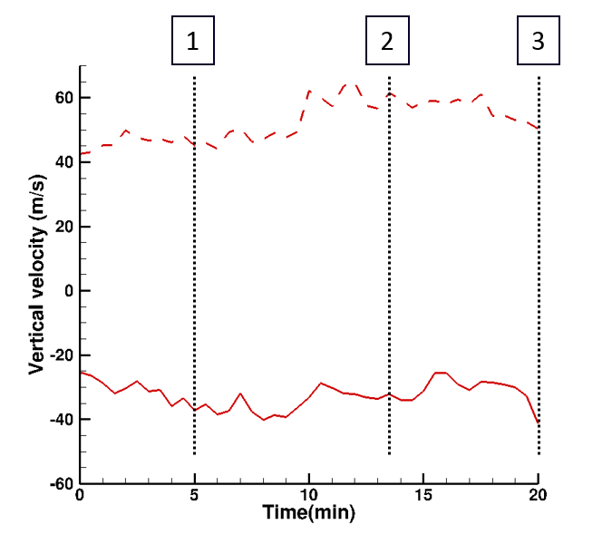

Figure 38. Vertical velocity History inside the domain for the reference case. The plain red line represents the minimum vertical velocity, and the dash red line the maximum vertical velocity.

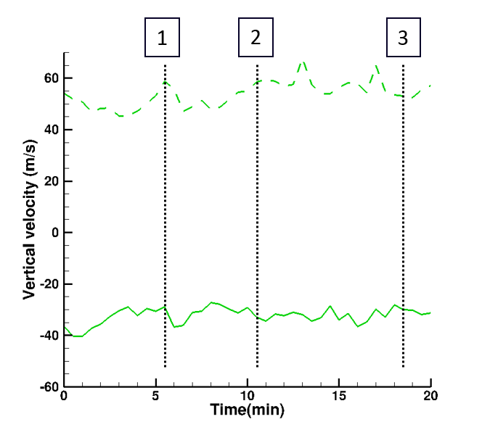

Figure 39. Vertical velocity History inside the domain for the wet case. The plain green line represents the minimum vertical velocity, and the dash green line the maximum vertical velocity.

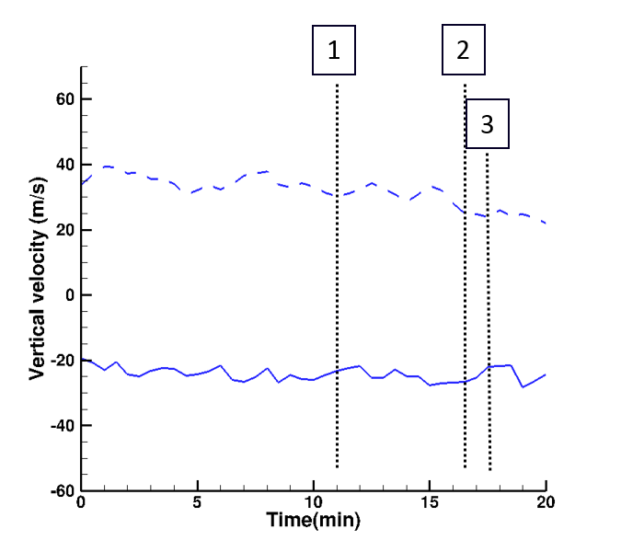

Figure 40. Vertical velocity History inside the domain for the dry case. The plain blue line represents the minimum vertical velocity, and the dash blue line the maximum vertical velocity.

### Vorticity

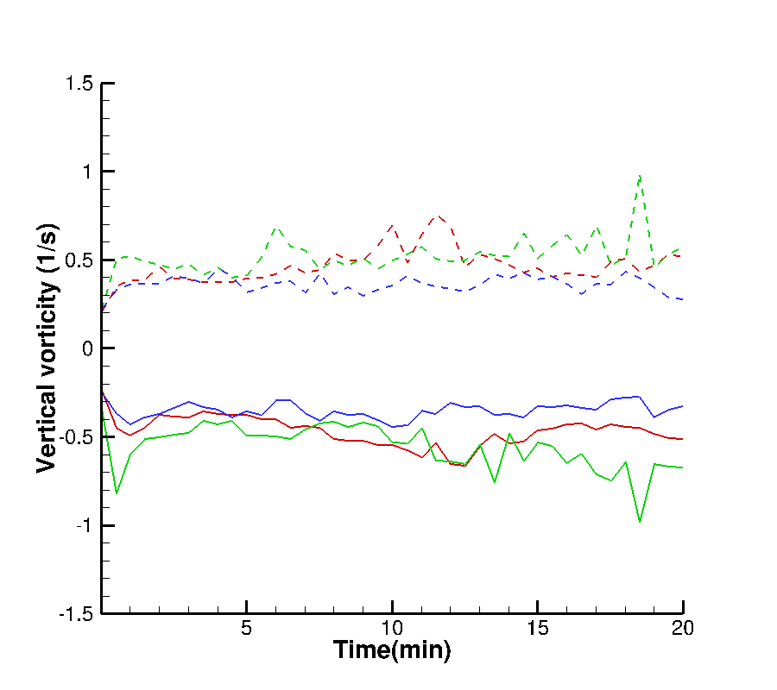

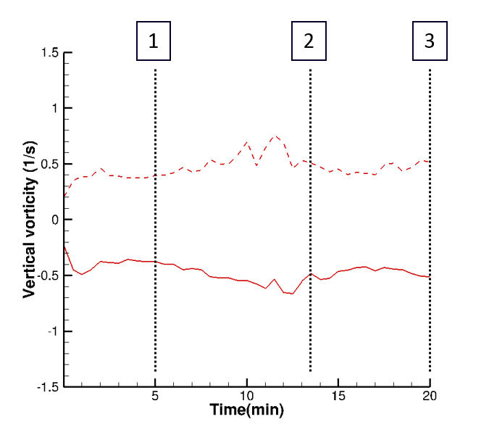

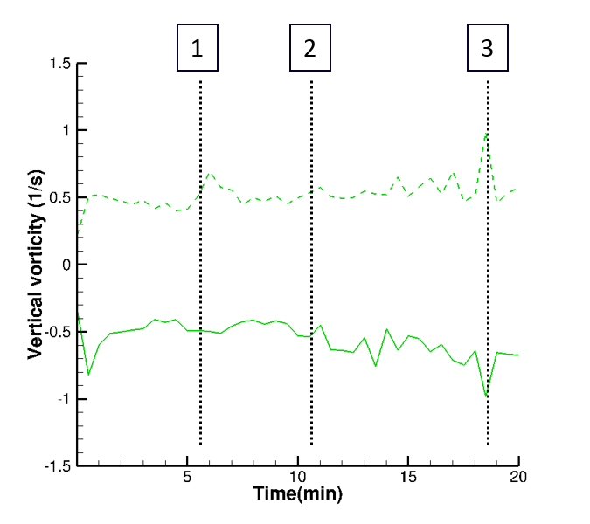

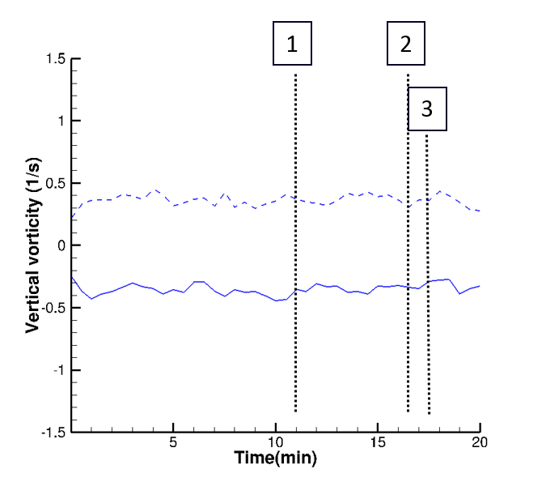

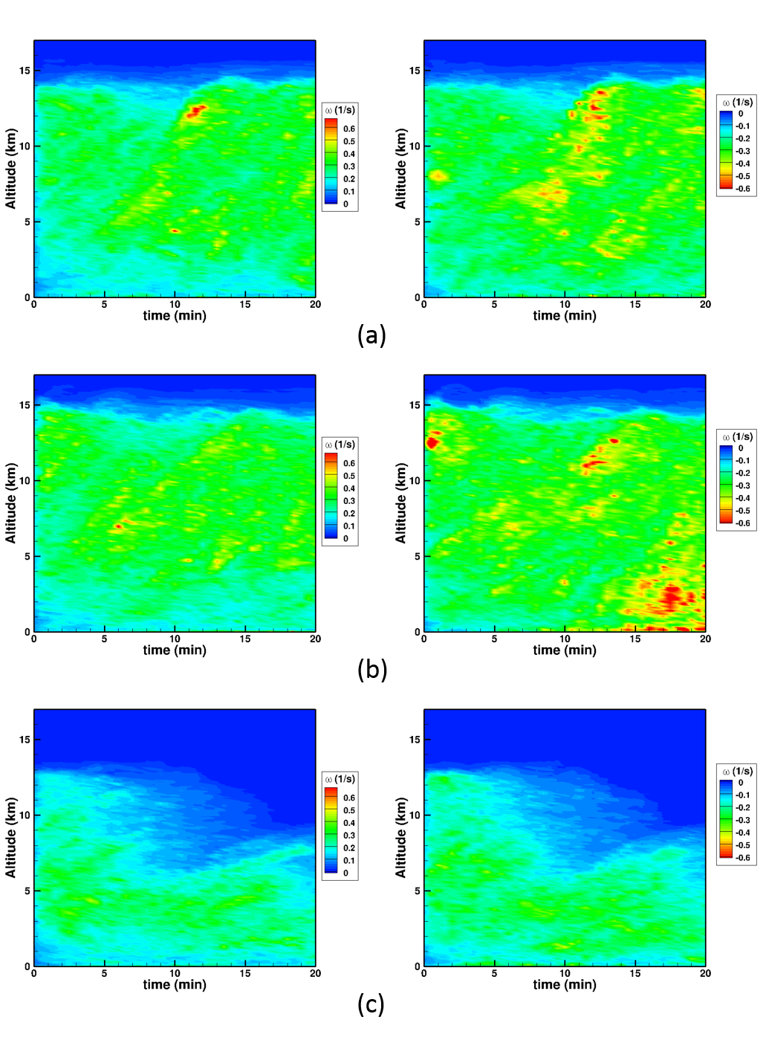

### Reynolds stresses

The Reynolds stresses were calculated over a time frame of 2.5 min. Figures 41, 42, and 43 represent the domain slices of Reynolds stresses for the three cases at a specific time and location. The time and location of the slices were selected based on the previous results obtained for the pressure, described previously. For each case, the opted time is the time when the first pression depression occurred, i.e. 5 min of simulation for the reference case, 5.5 min for the wet case, and 11 min for the dry case. Similarly, the slices are extracted using the location where the maximum pressure depression occurs. We can notice that the Reynolds stresses for the dry case are weaker than the other two cases. The “pockets” of Reynolds stresses of this case are also happening at a lower attitude compared to the reference and wet cases. The moisture of the atmosphereseems to reenforce the strength of the stresses, as the stronger intensity of stresses of the wet case is compared to the reference and dry cases. We can also notice, by the number of small “pockets” of stresses, the Reynolds stresses are not well organized.

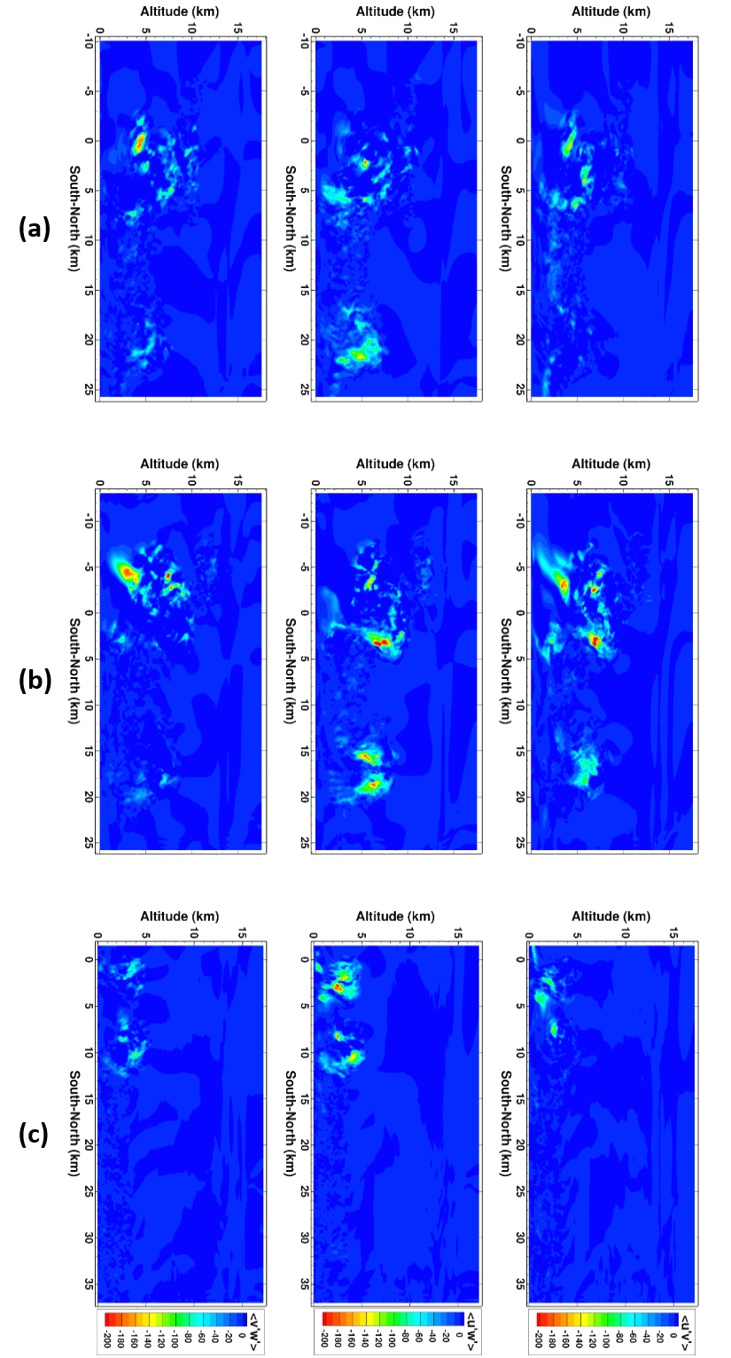

Figure 41. Reynolds stresses in the South-North plane for (a) the reference case, (b) the wet case, and (c) the dry case.

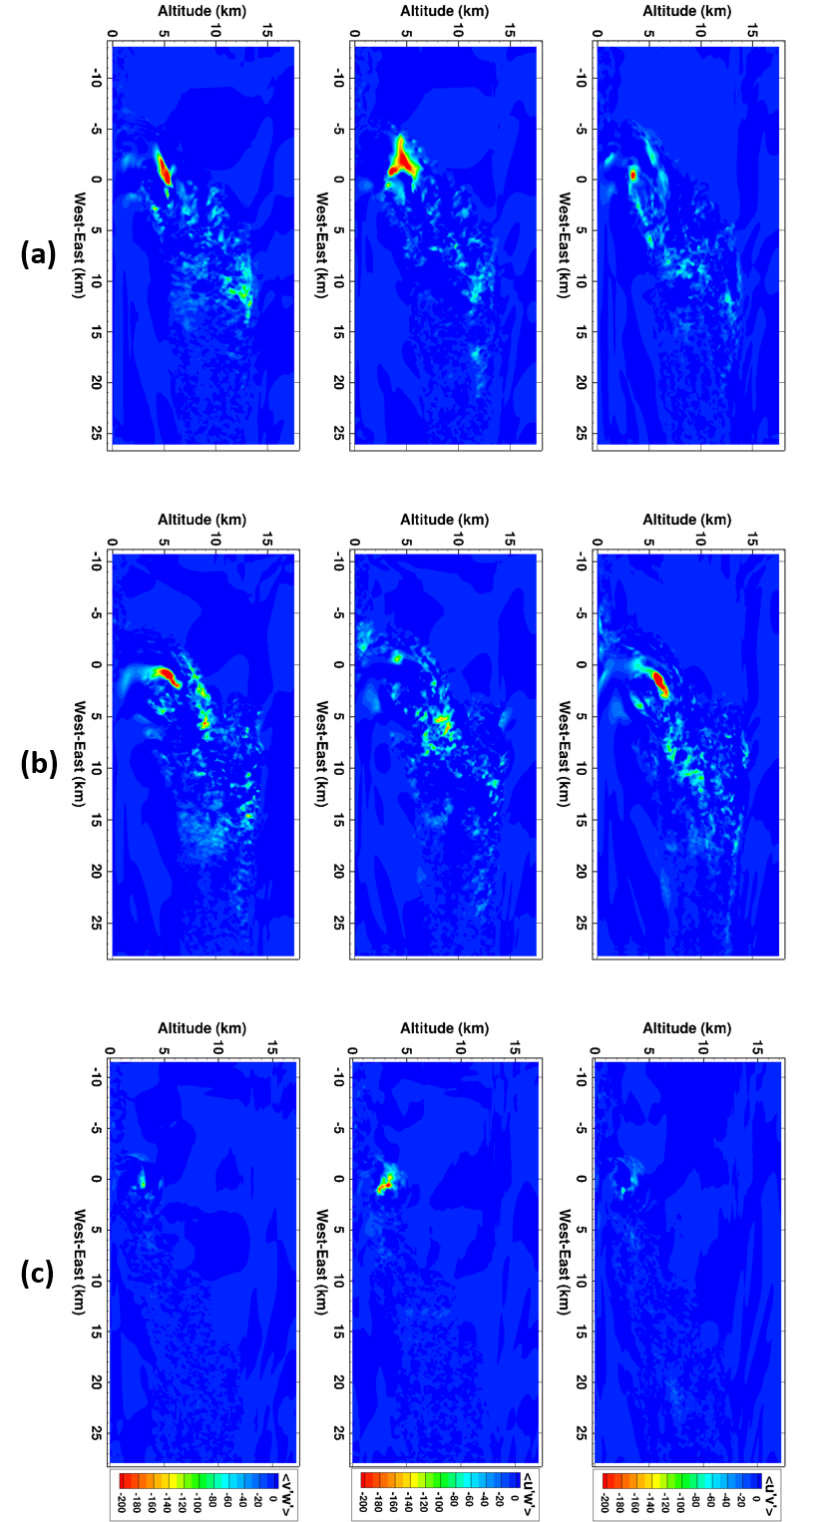

Figure 42. Reynolds stresses in the West-East plane for (a) the reference case, (b) the wet case, and (c) the dry case.

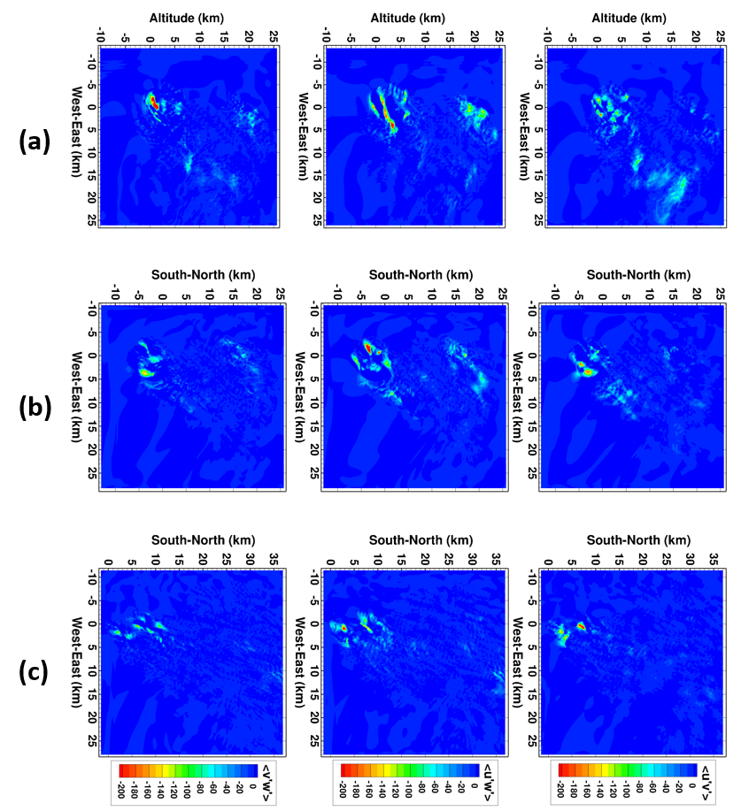

Figure 43. Reynolds stresses in the altitude plane for (a) the reference case, (b) the wet case, and (c) the dry case.

Summary and conclusion

# References

Ackerman and Knox, 2007. Meteorology, Understanding the Atmosphere. 2nd Edition Thomson Brooks/Cole.

Ahmad, 2011. Advection of Microphysical Scalars in Terminal Area Simulation System (TASS). 49th AIAA Aerospace Sciences Meeting, AIAA 2011-1004.

Ahmad, Proctor, 2011. Large Eddy Simulations of Severe Convection Induced Turbulence. 3rd AIAA Atmospheric Space Environments Conference, AIAA 2011-3201.

Air Weather Service, 1979. The use of the Skew T, Log P Diagram in analysis and forecasting. AWS/TR-79/006. Dec 1979, revised Mar 1990.

AWS, 1961. Use of the skew *T*-log *p* diagram in analysis and forecasting. Vol. 1. AWSM 105–124, 144 pp.

Barnes, 1970. Some aspects of a severe, right-moving thunderstorm deduced from mesonetwork rawinsonde observations. J. Atmos. Sci., 27, 634-648.

Bieringer and Ray, 1996. A Comparison of Tornado Warning Lead Times with and without NEXRAD Doppler Radar. Wea. Forecasting,11, 47–52.

Bluestein, 1998. A history of Severe-Storm-Intercept Field Programs. Weather and Forecasting, 14, 558-577.

Bluestein, French, Tanamachi, Frasier, Hardwick, Junyent, and Pazmany, 2007. Close-Range Observations of Tornadoes in Supercells Made with a Dual-Polarization, X-Band, Mobile Doppler Radar, Mon. Wea. Rev., Vol. 135, pp. 1522-1543.

Brooks, and Wilhelmson, 1992. Hodograph curvature and Updraft Intensity in numerically Modeled Supercells. J. Atmos. Sci., 50, 1824-1833.

**Ciesielski**, **Johnson, Haertel, and Wang, 2003.** Corrected TOGA COARE Sounding Humidity Data: Impact on Diagnosed Properties of Convection and Climate over the Warm Pool. Climate, 16, 2370–2384.

Davies, 1994. A look At Hodographs, Helicity, and Supercells. Storm Track, Jan/Feb 1994.

Davies and Johns, 1993. Some wind and instability parameters associated with strong and violent tornadoes. Part I: Wind shear and helicity. The tornado: Its Structure, Dynamics, Prediction, and Hazards, Geophys. Monogr., No. 79, Amer. Geophys. Union, 573-582.

Davies-Jones, 1984. Streamwise vorticity: the origin of updraft rotation in supercell storms. J. Atmos. Sci., 41, 2991-3006.

Davies-Jones, 2008. Can a Descending Rain Curtain in a Supercell Instigate Tornadogenesis Barotropically? J. Atmos. Sci.*,* 65, 2469–2497.

Davies-Jones and Kessler, 1974. Tornadoes. Weather and climate modification, W.N. Hess, Ed., Wiley, 552-595.

Doswell, 1991. A review for forecasters on the application of hodographs to forecasting. Natl. wea. Dig., 16 (1), 2-16

Doswell and Burgess, 1993. Tornadoes and tornadic storms: a review of conceptual models. The tornado: its structure, dynamics, prediction, and hazards. Geophys. Monogr. Amer. Geophys. Union, 50, 161-172.

Doswell, 2001. Storm Chasing with Safety, courtesy, and Responsibility. Accessed on May 20th, 2015. <http://www.cimms.ou.edu/~doswell/Chasing2.html>

Droegemeier, Lazarus and Davies-Jones, 1993. The influence of helicity on numerically simulated convective storms. Mon. Wea. Rev., 121, 2005-2029.

Faller, 1966. A numerical study of the instability of the laminar Ekman boundary layer. J. Atmos. Sci., 23, 466-480.

Fiedler, 1995. On modeling tornadoes in isolation from the parent storm. Atmos.–Ocean, 33, 501–512.

Gilmore and Wicker, 1998. The Influence of Midtropospheric Dryness on Supercell Morphology and Evolution. Mon. Wea. Rev., 126, 943–958.

Howells, Rotunno, and Smith, 1988. A comparative study of atmospheric and laboratory-analogue numerical tornado-vortex models. Q. J. R. Meteorol. Soc, 114, 801-822.

James, and Markowski, 2009. A Numerical Investigation of the Effects of Dry Air Aloft on Deep Convection. Mon. Wea. Rev.,138, 140-161.

Kerr and Darkow, 1996. Storm-Relative Winds and Helicity in the Tornadic Thunderstorm Environment. Wea. Forecasting, 11, 489–505.

Klemp and Wilhelmson, 1978. The simulation of three-dimensional convective storm dynamics. J. Atmos. Sci., 35, 1070-1110.

Klemp and Rotunno, 1983. A study of the tornadic region within a supercell thunderstorm. J. Atmos. Sci., 40, 359-377.

Kulie, Lin, Deal, DeCroix, Feb 1996. A cloud-scale simulation of the 28 November 1988 Raleigh tornadic thunderstorm. Preprints, 18th Conference on Severe Local Storms, San Francisco, CA, Amer. Meteor. Soc., 283-287.

Lewellen, Lewellen, and Sykes, 1997. Large-eddy simulation of a tornado’s interaction with the surface. J/ Atmos. Sci., 54, 581-605.

Lemon and Doswell, 1979. Severe thunderstorm evolution and mesosyclone structure as related to tornadogenesis. Mon. Wea. Rev., 107, 1184-1197.

Leslie, 1971. The development of concentrated vortices: a numerical study. J. Fluid Mech., 48, 1-21.

Lewellen, Lewellen, and Xia, 2000. The influence of a local swirl ratio on tornado intensification near the surface. J. Atmos. Sci., 57, 527-544.

Lilly, D. K., 1966: On the instability of Ekman boundary flow. J. Atmos. Sci., 23, 481–494

Lilly, 1986. The structure, energetic, and propagation of rotating convective storms. Part II: Helicity and storm stabilization. J. Atmos. Sci., 43, 126-140.

Markowski, 2002. Hook echoes and rear-flank downdrafts: A review. Mon. Wea. Rev., 130, 852-876.

Markowski, Hannon, Frame, Lancaster, Pietrycha, Edwards, and Thompson, 2003. Characteristics of Vertical Wind Profiles near Supercells Obtained from the Rapid Update Cycle. Wea. Forecasting, 18, 1262–1272.

Markowski and Richardson, 2009. Tornadogenesis: our current understanding, forcasting considerations, and questions to guide future research. Atm. Research, 93, 3-10.

National Weather Service. Event Summary, April 16, 2011 North Carolina Tornado Outbreak. Updated 02/03/2012.

National Weather Service. April 16, 2011 - Tornado Damage Survey

National Weather Service Eastern Region of North Carolina, April 18, 2011. April 16, 2011 – Survey for Raleigh, N.C.

Nora and Niino, 2003. Critical grid size for simulating convective storms: A case study of the Del City supercell storm. Geophys. Res. Lett., 30, 1844.

Nowotarski, Markowski, Richardson, and Bryan, 2014. Properties of a Simulated Convective boundary Layer in an Idealized Supercell. Amer. Meteor. Soc., 142, 3955-3975.

Proctor, 1983. A numerical study on the evolution of tornadoes. Dissertation.

Proctor, F. H., 1987: The Terminal Area Simulation System. Volume I: Theoretical formulation. NASA Contractor Rep. 4046, NASA, Washington, DC, 176 pp.

Proctor, F. H., 1987: The Terminal Area Simulation System. Volume II: Verification experiments. NASA Contractor Rep. 4047, NASA, Washington, DC, 112 pp.

Proctor, Hamilton, Switzer, 2006. TASS Driven Algorithms for Wake Prediction. 44h AIAA Aerospace Sciences Meeting, AIAA 2006-1073.

Proctor, Ahmad, Limon Duparcmeur, 2012. Numerical simulation of a tornado generating supercell. 50th AIAA Aerospace Sciences Meeting, AIAA 2012-0557.

Rotunno, 1977. Numerical simulation of a laboratory vortex. J. atmos. Sci., 34, 1942-1956.

Rotunno, 1981. On the evolution of thunderstorm rotation. Mon. Wea. Rev., 109, 577-586.

Rotunno and Klemp, 1985. On the rotation and propagation of simulated supercell thunderstorms. J. Atmos. Sci., 42, 271-292.

Rotunno, Klemp and Weisman, 1988. A theory for strong long-lived squall lines. J. Atmos. Sci., 45,463-485.

Shabbot and Markowski, 2006. Surface in situ observations within the outflow of forward-flank downdrafts of supercell thunderstorms. Mon. Wea. Rev., 134, 1422-1441.

Szeto and Cho 1994. A Numerical Investigation of Squall Lines. Part III: Sensitivity to Precipitation Processes and the Coriolis Force. J. Atmos. Sci., 51, 1341–1351.

Thompson, 2006. Explanation of SPC Severe Weather Parameters. Storm Prediction Center. Retrieved 2015-06-16.

Thompson, Edwards, Hart, Elmore and Markowski, 2003. Close proximity soundings within supercell environments obtained from the rapid update cycle. Amer. Meteor. Soc., 18, 1243-1260.

Thompson, Mead, and Edwards, 2007. Effective Storm-Relative Helicity and Bulk Shear in Supercell Thunderstorm Environments. Wea. Forecasting, 22, 102–115.

Shabbot and Markowski, 2006. Surface in situ observations within the outflow of forward-flank downdrafts of supercell thunderstorms. Mon. Wea. Rev., 134, 1422-1441.

Smagorinsky, 1963. General circulation experiments with the primitive equations, I. the basic experiment. Mon. Wea. Rev., 91, 99-164.

Switzer, 1996. Validation Tests of TASS for Application to 3-D Vortex Simulations. NASA CR-4756, 45pp.

Switzer and Proctor, 2014. Terminal Area Simulation System User’s Guide – Version 10.0. NASA/TM-2014-218150, 91pp.

Vreman, 2004. An eddy-viscosity subgrid-scale model for turbulent shear flow: Algebraic theory and applications. Phys. of Fluids, 16, 3670-3681.

Wind Science and Engineering Center, 2006. A recommendation for an Enhanced Fujita Scale (EF-Scale), Revision 2. Texas Tech University, October 10, 2006.